Hungary
Chronology
9 BC - c.400 AD West of the Danube River part of the Roman Empire.
c.400 - 454 Hun rule based in Pannonia.
454 - 526 Ostrogothic rule (see Italy).
526 - Apr 568 Lombard (Langobard) rule (see Italy).
Apr 568 - c.805 Avar rule Pannonia.
c.805 - c.896 Frankish rule west of the Danube River, Bulgarian
rule to the east of the Danube.
c.896 Hungarian (Magyar) settlement of the Danube plain.
25 Dec 1000 Kingdom of Hungary (Regnum Hungariae/Magyar Királyság).
1102 - 1918 Croatia attached to the Kingdom of Hungary as claimed in the Pacta Conventa.
11 Apr 1241 - 1242 Mongol invasion and occupation devastates large areas of Hungary.
8 Sep 1290 - 18 Aug 1295 Carlo Martello of Naples, son of Mária of Hungary
the daughter of King István V, is set up by Pope
Nicholaus IV as King of Hungary, as the successor
of his uncle the childless László IV, against
whom Pope had already earlier declared a crusade.
14 Jan 1301 End of the founding Árpád dynasty.
4 Feb 1403 - Oct 1403 Insurrection in Croatia as Ladislao II of Naples
tries to restore Angevin rule in Hungary and is
crowned King of Hungary at Zara in Dalmatia
15 May 1440 - 16 Dec 1442 Civil war erupts when the infant heir, László VI
"Utószülött" ("the Postumous"), is crowned
King, but the Diet of Hungary declares his
coronation invalid and elects the Polish
monarch as King. Guardianship over László VI is
given over to Habsburg Friedrich V Archduke
of Austria 23 Aug 1440 - 4 Sep 1452.
29 Jun 1440 - 10 Nov 1444 Personal union with Poland.
29 Jun 1490 - 29 Aug 1526 Personal union with Bohemia under the Jagiello
(Jagelló) dynasty.
17 Nov 1490 Habsburg Maximilian of Austria claims the crown
(by right of the 1463 treaty of succession) taking
Székesfehérvár (Stuhlweissenburg), which is
occupied until 29 Jul 1491.
7 Nov 1491 Maximilian waives his claim in exchange for renewed
right of succession (ratified 6 Dec 1491).
29 Aug 1526 At Battle of Mohács the Ottoman Empire defeats
Hungarian and Bohemian forces killing King Lajos
II and pillaging Buda.
10 Nov 1526 János Szápolyai (Zápolyai) voivode of Transylvania
is elected king of Hungary and crowned next day.
16 Dec 1526 Habsburg Archduke of Austria Ferdinand is elected
King of Hungary, he ousts János on 20 Aug 1527 by
capturing the capital and is formally crowned on
3 Nov 1527.
16 Dec 1526 - 11 Nov 1918 In personal union with Austria under the Habsburg
20 Aug 1527 Ferdinand I occupies Buda and Szápolyai flees to
(from 29 Nov 1780, Habsburg-Lothringen) dynasty.
Poland. Szápolyai is defeated again 20 Mar 1528.
14 Sep 1529 - 21 Jul 1540 János I Szápolyai is restored by Ottoman
intervention and submits to Ottoman suzerainty.
24 Feb 1538 Hungarian civil war terminated by the Treaty of
Nagyvárad (or Grosswardein), both parties
(Habsburg Archduke Ferdinand I and former voivode
of Transylvania János Szápolyai [Zápolyai])
are recognized and both keep the title "king of
Hungary" and their current territories (Szápolyai
in eastern and Ferdinand in western or royal
Hungary), the potential Szápolyai heir becomes
a "duke" only (peace ratified 10 Jun 1538).
29 Aug 1541 Ottoman rule in Buda (Ofen) by submission.
Danube/Tisza area becomes an Ottoman province,
Ottoman intervention reduces the Habsburg
sphere, the area beyond Tisza River remains
under Transylvania rule under János II (in
opposition to Ferdinand).
29 Aug 1541 - 26 Jan 1699 Partitioned between Austria and Ottoman Empire.
19 Jun 1547 - 11 Nov 1606 Austrian Hungary tributary to the Ottoman Empire.
2 Sep 1686 Austrian Habsburg forces liberate Buda (Ofen).
26 Jan 1699 Austrian Habsburgs expel remaining Ottoman forces.
19 Jul 1831 - Aug 1831 Great peasant uprising in north eastern Hungary.
15 Mar 1848 Hungarian Revolution of 1848 begins.
11 Apr 1848 The "March Laws" are confirmed by King Ferdinánd
(withdrawn on 22 Nov 1848).
13 Dec 1848 Austrian invasion begins (occupying Buda [Ofen]
and Pest on 5 Jan 1849, briefly retaken by the
revolutionaries 21 May - 18 Jul 1849).
14 Apr 1849 - 13 Aug 1849 Independence from Austria declared (Hungary
[Magyarország]).
17 Jun 1849 Russian begins invasion on behalf of Austria.
13 Aug 1849 Hungarian Kingdom (A Magyar Királyság)(personal
union with Austria restored).
13 Aug 1849 Hungarian rebellious government surrenders (later
capitulations of fortresses: 26 Aug 1849 Munkács,
5 Sep 1849 Peterwardein and 27 Sep 1849 Komorn).
24 Oct 1849 Austria dis-annexes Croatia and Transylvania
from Hungary and Hungary is divided into five
military districts (Pressburg, Kaschau,
Grosswardein, Pest-Ofen, and Ödenburg) and (18 Nov
1849 - 27 Dec 1860) the governorate of Temesch,
and the Serbian Vojvodina.
13 Sep 1850 Provisional civil administration established.
20 Oct 1860 Hungarian diet is restored, limited self-rule.
21 Dec 1867 - 11 Nov 1918 "Hungarian half" of the Austro-Hungarian Monarchy
(Osztrák-Magyar Monarchia = Österreichisch-
Ungarische Monarchie)(as "Lands of the Holy
Hungarian Crown")(A Magyar szent korona országok =
Länder der ungarischen heiligen Krone)(incl.
Croatia, Fiume, Slavonia and Transylvania).
17 Oct 1918 Hungarian government terminates the 1867 Compromise,
to end the personal union with Austria 31 Oct.
29 Oct 1918 Croatia declares end of its union with Hungary and
the Croat and Slovene State is declared.
30 Oct 1918 Slovak National Council declares itself part of
the Czechoslovak State.
31 Oct 1918 Hungarian personal union with Austria declared ended.
13 Nov 1918 King Károly IV declares his withdrawal from politics
(which was made public 14 Nov 1918, and accepted by
session of Hungarian National Council 16 Nov 1918)
16 Nov 1918 Hungarian People's Republic (A Magyar Népköztársaság)
19 Nov 1918 All references to "royal" in legal acts are abolished
by government regulation.
21 Mar 1919 Hungarian Conciliar ("Soviet") Republic (A Magyar
Tanácsköztársaság).
5 May 1919 - 22 Aug 1919 Hungary (Magyarország)(counter-revolutionary
government at Arad, then Szeged).
23 Jun 1919 - 1 Aug 1919 Socialist Federative Soviet Republic of Hungary
(A Magyarországi Szocialista Szövetséges
Tanácsköztársaság).
2 Aug 1919 - 6 Aug 1919 Hungarian People's Republic (A Magyar Népköztársaság)
4 Aug 1919 - 14 Nov 1919 Occupied by Rumania.
7 Aug 1919 Hungary (Magyarország)
29 Feb 1920 - 28 Mar 1945 Hungarian State (A Magyar Állam)(other names in
official use: Hungary [Magyarország] and Hungarian
Kingdom [A Magyar Királyság]).
18 Mar 1920 References to "royal" in legal acts are restored by
government order.
4 Jun 1920 Hungary reduced to ethnic core. Hungary formally
surrenders Fiume; cedes Croatia, Slavonia,
Vojvodina, western Banat, Bosnia-Hercegovia,
and Prekmurje-Medjimurje to Serb-Croat-Slovene
state; Transylvania and eastern Banat are
ceded to Romania; Carpatho-Ruthenia, Slovakia
(including Pozsony/Pressburg [Bratislava]) are
ceded to Czechoslovakia; and West Hungary
(Burgenland) is ceded to Austria by the Treaty
of Trianon (ratified on 21 Jun 1921).
20 Oct 1921 - 24 Oct 1921 Attempted restoration of the Habsburg monarchy;
Habsburg rights to throne are voided 6 Nov 1921.
10 Nov 1938 - May 1945 Southern regions of Slovakia and Subcarpathia
(also annexed 16 Mar 1939) ceded to Hungary.
30 Aug 1940 - 11 Mar 1945 Northern Transylvania annexed from Romania.
11 Apr 1941 - 17 Oct 1944 Bačka (Bácska), Baranja, Međimurje (Muraköz), and
Prekmurje (Muravidék) annexed from Yugoslavia.
1 Apr 1944 - 4 Apr 1945 German occupation.
19 Oct 1944 - 15 Sep 1947 Allied (Soviet) occupation.
21 Dec 1944 Provisional National Assembly convenes in Debrecen.
21 Dec 1944 Hungary (Magyarország).
31 Jan 1946 Hungarian Republic (A Magyar Köztársaság).
10 Feb 1947 Frontiers of Hungary as of 1 Jan 1938 restored
by Paris Peace Treaty (ratified 15 Sep 1947).
20 Aug 1949 Hungarian People's Republic (A Magyar Népköztársaság)
23 Oct 1956 - 11 Nov 1956 Anti-Communist rebellion, ended by invasion of
Soviet Union and Warsaw Pact forces.
23 Oct 1989 Hungarian Republic (A Magyar Köztársaság).
1 Jan 2012 Hungary (Magyarország).
1 May 2004 Part of European Union.
General secretaries (28 Jun 1953 - 28 Mar 1985, first secretaries) of the Hungarian
Communist Party (from 12 Jun 1948, Hungarian Workers' Party; from 2 Nov 1956,
Hungarian Socialist Workers' Party)
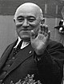 | Feb 1945 - 18 Jul 1956 Mátyás Rákosi  (b. 1892 - d. 1971)
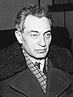 | 18 Jul 1956 - 25 Oct 1956 Ernö Gerö  (b. 1898 - d. 1980)
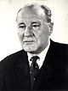 | 25 Oct 1956 - 22 May 1988 János Kádár  (b. 1912 - d. 1989)
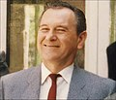 | 22 May 1988 - 7 Oct 1989 Károly Grósz  (b. 1930 - d. 1996)
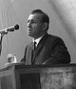 | 24 Jun 1989 - 7 Oct 1989 Rezsö Nyers (president) (b. 1923 - d. 2018)
Ruler (style Gyula)
 | 8.. - 904 Kurszán (Kussan) (d. 904)
 | Rulers (style Kende)
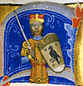 | c.895 - 907 Árpád fia Álmos (b. 85. - d. 907)
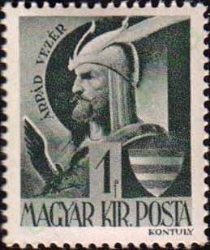
 | 907 - 92. Tarhos fia Árpád (b. 87. - d. 92.)
 | 92. - 92. Üllő fia Árpád (b. 88. - d. 92.)
 | 92. - c.933 Jutas fia Árpád (b. 88. - d. 93.)
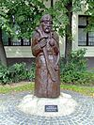 | c.933 - c.947 Solt (Zoltán) fia Árpád (b. 89. - d. c.947)
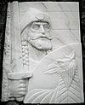 | c.947 - Oct? 955 Fajsz (Falicsi) fia Jutas (b. 90. - d. 955?)
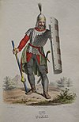 | Oct? 955 – 971 Taksony fia Solt (b. 92. – d. 971)
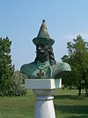 | 971 - 1 Feb 997 Gyécsa (Géza) fia Taksony (b. c.943 - d. 997)
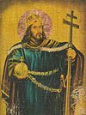 | 1 Feb 997 - 25 Dec 1000 Vajk István fia Gyécsa (b. c.969 - d. 1038)
Kings¹ (1526-1849, also rulers of Austria)
House of Árpád (1000–1301)
25 Dec 1000 - 15 Aug 1038 István I ("Szent István")
(= Vajk István)("Saint Stephen") (s.a.)
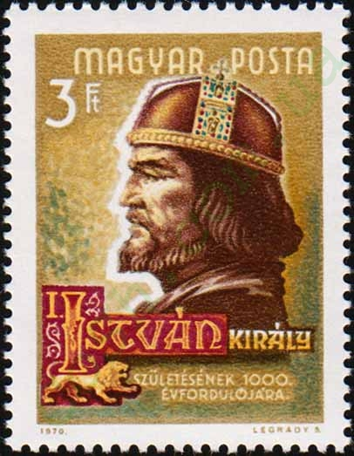
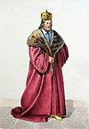 | 15 Aug 1038 - 1041 Péter I (1st time) (Pietro di Ottone Orseolo)  (b. 1012 - d. 1060)
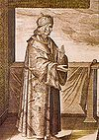 | 1041 - 5 Jul 1044 Sámuel Aba (b. c.990 - d. 1044)
 | 5 Jul 1044 - Oct? 1046 Péter I (2nd time) (s.a.)
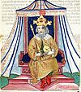 | Oct? 1046 - 6 Dec 1060 András I "Fehér" ("White") (Endre I)  (b. 1014 - d. 1060)
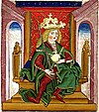 | 6 Dec 1060 - Aug 1063 Béla I "Bajnok" (Adalbert)  ("the Champion")  (b. 1016 - d. 1063)
Jul 1063 - 1063 .... -Palatine
(ex officio locum tenens regius)
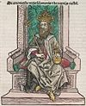 | 1063 - 14 Mar 1074 Salamon (Salomon)  (b. 1052 - d. 1087)
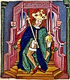 | 14 Mar 1074 - 25 Apr 1077 Géza I (Geyza I) (Magnus)  (b. c.1044 - d. 1077)
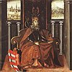 | 25 Apr 1077 - 29 Jul 1095 László I ("Szent László") ("Saint Ladislaus") (b. c.1046 - d. 1095

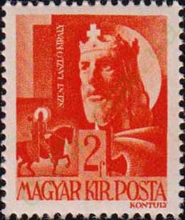
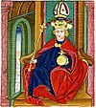 | 29 Jul 1095 - 3 Feb 1116 Kálmán "Könyves" (Colomanus)  ("the Book-Lover") (b. c.1065 - d. 1116)
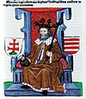 | 3 Feb 1116 - 1 Mar 1131 István II (Stephanus)  (b. 1101 - d. 1131)

1 Mar 1131 - 28 Apr 1131 .... –Palatine
(ex officio locum tenens regius)
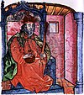 | 28 Apr 1131 - 13 Feb 1141 Béla II "Vak" ("the Blind")  (b. 1109 - d. 1141)
1131 - 22 Jul 1132 Borisz (Borić) (pretender) (1st time)
(b. c.1114 - d. af.1155)
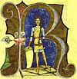 | 13 Feb 1141 - 31 May 1162 Géza II (Geyza II)  (b. c.1130 - d. 1162)
13 Feb 1141 - 1147 Belos (Beloš Urošić) -Regent
(b. 111. - d. af.1163)
 | 1146 - 11 Sep 1146 Borisz (pretender) (2nd time) (s.a.)
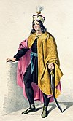 | 31 May 1162 - 15 Jul 1162 István III (1st time)  (b. 1147 - d. 1172)
31 May 1162 - 15 Jul 1162 Regents
- Lukács Bánfi, érsek Esztergomi (b. c.1120 - d. 1181)
- Hendrik Héder -Palatine
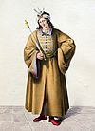 | 15 Jul 1162 - 14 Jan 1163 László II (Ladizlaus)  (b. 1132 - d. 1163)
 | 14 Jan 1163 - 27 Jan 1163 Hendrik Héder (acting)
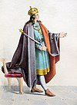 | 27 Jan 1163 - 4 Mar 1172 István III (2nd time) (s.a.)
27 Jan 1163 - 11 Apr 1165 István IV (pretender)
(b. 1133 - d. 1165)
4 Mar 1172 - 13 Jan 1173 Ampud -Palatine
(ex officio locum tenens regius)
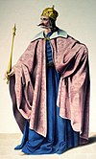 | 13 Jan 1173 - 23 Apr 1196 Béla III  (b. 1148 - d. 1196)
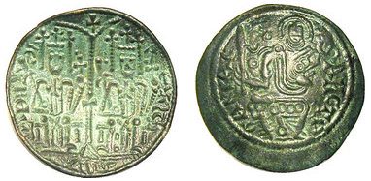
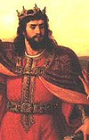 | 23 Apr 1196 - 30 Nov 1204 Imre (Hemericus)  (b. 1174 - d. 1204)
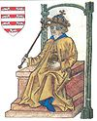 | 30 Nov 1204 - 7 May 1205 László III (Ladizlaus)  (b. 1199 - d. 1205)
30 Nov 1204 - 29 May 1205 András, herceg Dalmáciai -Regent
(b. 1176 - d. 1235)
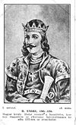 | 29 May 1205 - 21 Sep 1235 András II "Jeruzálemi" (Endre II)  (= András, herceg Dalmáciai) (s.a.)
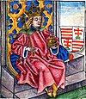 | 1214 - 3 May 1270 Béla IV (co-ruler to 21 Sep 1235)  (b. 1206 - d. 1270)
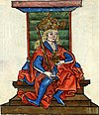 | 20 Aug 1245 - 6 Aug 1272 István V (co-ruler to 3 May 1270)  (b. 1239 - d. 1272)
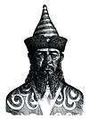 | 6 Aug 1272 - 10 Jul 1290 László IV "Kun" ("the Cuman")  (b. 1262 - d. 1290)
6 Aug 1272 - 23 May 1277 Erzsébet (Elisabeth)(f) - Regent
(b. 1240 - d. af.1290)
10 Jul 1290 - 23 Jul 1290 Mizse -Palatine
(ex officio locum tenens regius)
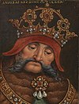 | 23 Jul 1290 - 14 Jan 1301 András III "Velencei" (Endre III)  ("the Venetian") (pretender in 1278)  (b. c.1266 - d. 1301)
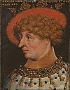 | 6 Jan 1292 - 19 Aug 1295 Károly Martell (= Carlo Martello) (pretender, in Naples)  (b. 1271 - d. 1295)
14 Jan 1301 - 27 Aug 1301 Amadé (Omode) fia Dávid nembeli Aba -Palatine (ex officio locum tenens regius)
(b. 12.. - d. 1311)
 | House of Přemyslid (1301–1305)
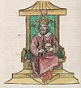 | 27 Aug 1301 - 9 Oct 1305 Ladizlaus (László V)  (also King of Poland Wacław III and Václáv III of Bohemia)  (b. 1289 - d. 1306)
9 Oct 1305 - 5 Dec 1305 Jakab Kopasz fia Tamás nembeli Borsa -Palatine (ex officio locum tenens regius)
(b. 12.. - d. 1317)
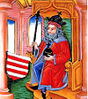 | 5 Dec 1305 - Jun 1307 Béla V  (also Duke of Bavaria Otto III von Wittelsbach)  (b. 1261 - d. 1312)
Jun 1307 - 10 Oct 1307 Palatines
- Loránd fia Lesuták nembeli Rátót (b. 12.. - d. af.1307)
- István fia Erne nembeli Ákos ( from Sep 1307) (b. 12.. - d. 131.)
- Máté fia Péter nembeli Csák (b. c.1252 - d. 1321)
- Amadé fia Dávid nemzetségi Alba (s.a.)
- Jakab Kopasz fia Tamás nembeli Borsa
(ex officio locum tenens regius) (s.a.)
 | House of Anjou (1308–1395)
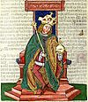 | 10 Oct 1307 - 16 Jul 1342 Károly I (Károly Róbert)  (b. 1288 - d. 1342)
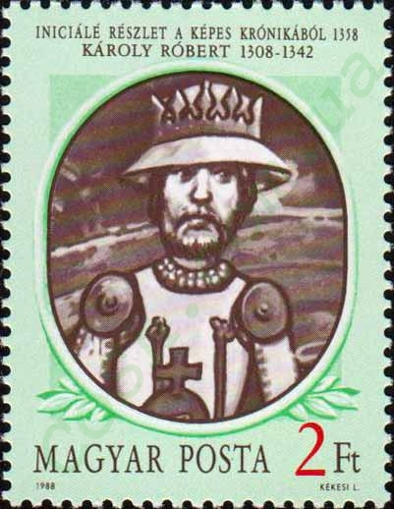
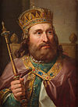 | 16 Jul 1342 - 11 Sep 1382 Lajos I "Nagy" ("the Great")  (from 5 Nov 1370, also King Ludwik I of Poland)  (b. 1326 - d. 1382)
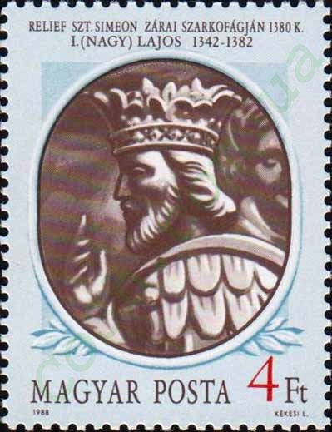
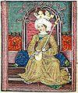 | 11 Sep 1382 - Dec 1385 Mária -Queen (1st time)  (b. 1371 - d. 1395)
11 Sep 1382 - 6 Oct 1385 Miklós Garai -Palatine
(ex officio locum tenens regius)
(b. 133. - d. 1386)
6 Oct 1385 - Dec 1385 Miklós Széchy felsőlendvai-Palatine
(ex officio locum tenens regius)
(b. 133. - d. 1387)
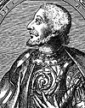 | Dec 1385 - 7 Feb 1386 Károly II "Kis" ("the Short")  (King Carlo III of Naples ["Sicily"])  (b. 1345 - d. 1386)
 | 7 Feb 1386 - 4 Sep 1386 Mária -Queen (2nd time) (s.a.)
25 Jul 1386 - 31 Mar 1387 Sigismund Markgraf zu Brandenburg (captain-general) (acting)
(b. 1368 - d. 1437)
 | House of Luxembourg (1387–1437)
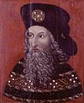 | 31 Mar 1387 - 9 Dec 1437 Zsigmond I "Luxemburgi"  (= Sigismund Markgraf zu Brandenburg)  (also King of Germany Sigismund and Zikmund of Bohemia) (s.a.)
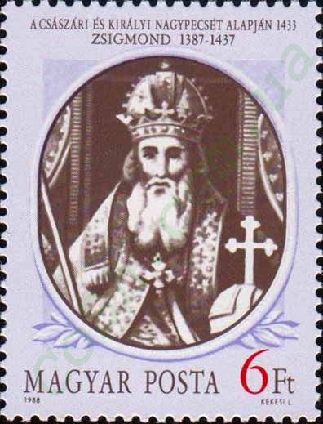
5 Aug 1403 - Oct 1403 László (V) "Nápolyi" ("Neapolitan")
(in dissidence, in Dalmatia)
(b. 1376 - d. 1414)
9 Dec 1437 - 1 Jan 1438 Lőrinc Hédervári -Palatine
(1st time) (ex officio locum tenens regius)
(b. 140. - d. 1447)
 | House of Habsburg (1437–1457)
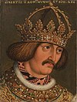 | 1 Jan 1438 - 27 Oct 1439 Albert  (from 15 Jun 1438, also Archduke of Austria  Albrecht V and King of Bohemia Albrecht)  (b. 1397 - d. 1439)
27 Oct 1439 - 29 Jun 1440 Lőrinc Hédervári -Palatine
(2nd time) ( ex officio locum tenens regius) (s.a.)
 | House of Jagiellon (1440–1444)
22 Feb 1440 - 16 Dec 1442 László VI (V) "Utószülött"
(= Duke of Austria Ladislaus "Postumus") (1st time)
(b. 1440 - d. 1457)
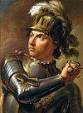 | 29 Jun 1440 - 10 Nov 1444 Ulászló I "Varnai"  (in Vienna 23 Aug 1440 - 4 Sep 1452)  (also King Władysław III of Poland)  (b. 1423 - d. 1444)
1 Sep 1444 - 6 Jun 1446 Lőrinc Hédervári -Palatine
(3rd time)(ex officio locum tenens regius) (s.a.)
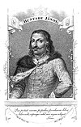 | 6 Jun 1446 - 9 Nov 1456 Vicar generals and governors  - János Hunyadi (to 11 Aug 1456) (b. c.1386 - d. 1456)  - László Garai (acting) (11 Aug 1456 - Oct 1456) (b. c.1410 - d. 1459)  - Ulrich Graf zu Cilly und Ortenburg (from Oct 1456)  (b. 1407 - d. 1456)
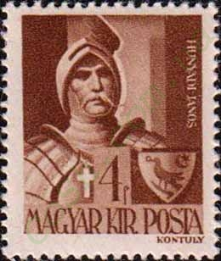
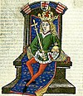 | 2. Jan 1453 - 23 Nov 1457 László VI (V) "Utószülött"  (2nd time) (s.a.)
23 Nov 1457 - 24 Jan 1458 László Garai -Palatine
(ex officio locum tenens regius) (s.a.)
 | House of Hunyadi (1458–1490)
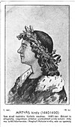 | 24 Jan 1458 - 6 Apr 1490 Mátyás I Hunyadi "Korvin" ("Raven")  (b. 1443 - d. 1490)
INCLUDEPICTURE "http://cosh.com.ua/img.php?cat=4&num=596" \* MERGEFORMATINET 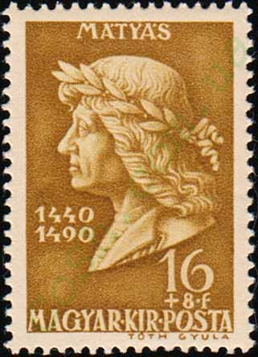 |  | INCLUDEPICTURE "http://cosh.com.ua/img.php?cat=4&num=594" \* MERGEFORMATINET 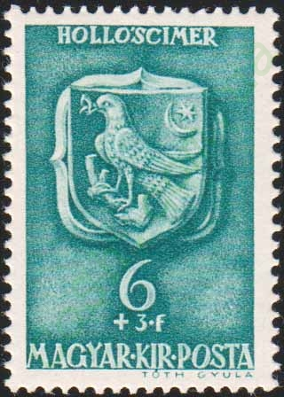
24 Jan 1458 - Aug 1458 Mihály Szilágyi horogszegi –Regent
(b. 141. - d. 1461)
4 Mar 1459 - 19 Jul 1463 Frigyes (in dissidence ) (also Holy Roman Emperor Friedrich III)
(b. 1415 - d. 1493)
5 Dec 1487 - 9 Aug 1490 Orbán Dóczi nagylúcsei, püspök Egri –Regent
(b. 143. - d. 1491)
 | House of Jagiellon (1490–1526)
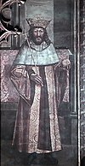 | 9 Aug 1490 - 13 Mar 1516 Ulászló II "Dobzse"  (also King of Bohemia Vladislav V)  (b. 1456 - d. 1516)
17 Nov 1490 - 7 Nov 1491 Miksa (in dissidence)
(also Holy Roman Emperor Maximilian I)
(b. 1459 - d. 1519)
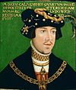 | 4 Jun 1508 - 29 Aug 1526 Lajos II (Ludwik)  (b. 1506 - d. 1526)
13 Mar 1516 - 11 Dec 1521 Regents
- Tamás bíboros Bakócz (Bakács) (to 11 Jun 1521) (b. 1442 - d. 1521)
- János Bornemisza (b. 14.. - d. 1527)
- Georg Markgraf zu Brandenburg in Ansbach (b. 1484 - d. 1543)
29 Aug 1526 - 11 Nov 1526 István Báthory ecsedi -Palatine
(ex officio Locum tenens regius)
(b. 147. - d. 1530)
 | House of Zápolya (1526–1570)
11 Nov 1526 - 20 Aug 1527 János I Szápolyai (Zápolyai) (1st time)
(b. 1487 - d. 1540)
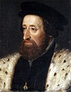 | 20 Aug 1527 - 14 Sep 1529 Ferdinánd I (1st time)  (also Archduke of Austria Ferdinand I)  (b. 1503 - d. 1564)
 | 14 Sep 1529 - 22 Jul 1540 János I Szápolyai (2nd time) (s.a.)
 | 24 Dec 1530 - 29 Sep 1534 Aloisio Gritti -Regent (b. 148. - d. 1534)
 | 14 Sep 1529 - 22 Jul 1540 Ferdinánd I (in dissidence) (s.a.)
 | 22 Jul 1540 - 25 Jul 1564 Ferdinánd I (2nd time) (s.a.)
13 Sep 1540 - 21 Jul 1551 János II (1st time) (in dissidence)
(= János Zsigmond Szápolyai [Zápolyai])
(b. 1540 - d. 1571)
13 Sep 1540 - 21 Jul 1551 Izabella Jagelló (f)
Regent (under János II, in dissidence)
(b. 1519 - d. 1559)
 | 22 Oct 1556 - 14 Mar 1571 János II (2nd time) (in dissidence) (s.a.)
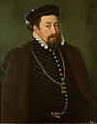 | 8 Sep 1563 - 12 Oct 1576 Miksa (co-ruler to 25 Jul 1564)  (also King Maxmilián I of Bohemia and from  25 Jul 1564 Holy Roman Emperor Maximilian II)  (b. 1527 - d. 1576)
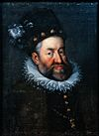 | 25 Sep 1572 - 19 Nov 1608 Rezsö (co-ruler to 12 Oct 1576)  (also Archduke of Austria Rudolf)  (b. 1552 - d. 1612)
20 Apr 1605 - 29 Dec 1606 István Bocskai bocskói-kismarjai,
fejedelem Erdélyi (in dissidence)
(b. 1557 - d. 1606)
21 Mar 1606 - 19 Nov 1608 Matthias Erzherzog zu Österreich -Regent
(b. 1557 - d. 1619)
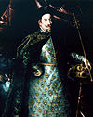 | 19 Nov 1608 - 1 Jul 1618 Mátyás II (= Matthias) (s.a.)
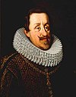 | 1 Jul 1618 - 15 Feb 1637 Ferdinánd II (b. 1578 - d. 1637)
 | House of Bethlen (1620–1621)
 | 25 Aug 1620 - 31 Dec 1621 Gábor (= Gábor Bethlen iktári) (in dissidence) (b. 1580 - d. 1629)
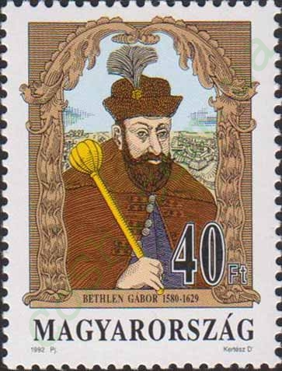 |  | 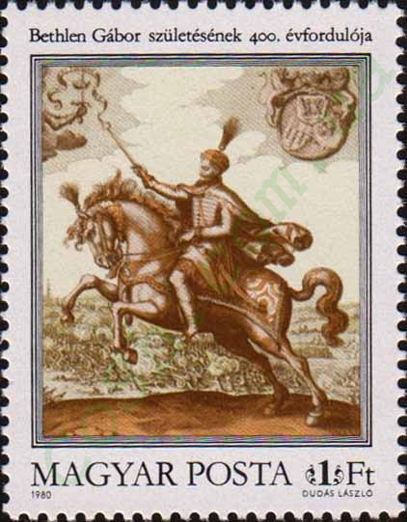
 | House of Habsburg (1526–1780)
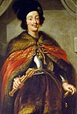 | 8 Dec 1626 - 2 Apr 1657 Ferdinánd III (co-ruler to 15 Feb 1637)  (b. 1608 - d. 1657)
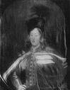 | 16 Jun 1647 - 9 Jul 1654 Ferdinánd IV -Co-ruler (b. 1633 - d. 1654)
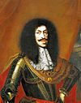 | 27 Jun 1655 - 5 May 1705 Lipót I (co-ruler to 2 Apr 1657)  (b. 1640 - d. 1705)
 | Eastern Hungarian Kingdom
 | 1526–1551 1556–1570
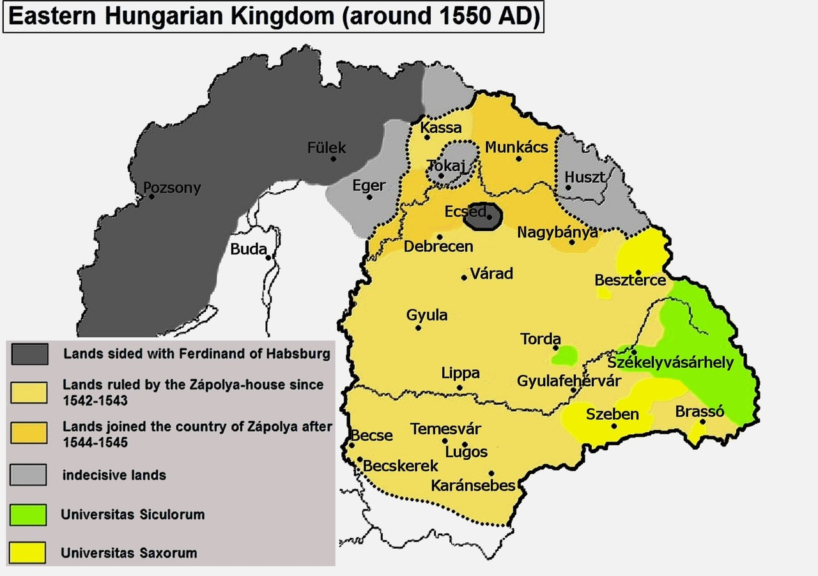
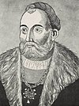 | Nov 1526 - 20 Aug 1527 János I Szápolyai (Zápolyai)  (1st time) (b. 1487 - d. 1540)
20 Aug 1527 - 14 Sep 1529 Ferdinánd I (1st time)
(also Archduke of Austria Ferdinand I)
(b. 1503 - d. 1564)
24 Dec 1530 - 29 Sep 1534 Aloisio Gritti -Regent
(b. 148. - d. 1534)
 | 14 Sep 1529 - 22 Jul 1540 János I Szápolyai (2nd time) (s.a.)
20 Aug 1527 - 14 Sep 1529 Ferdinánd I (1st time
(also Archduke of Austria Ferdinand I)
(b. 1503 - d. 1564)
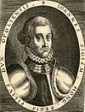 | 13 Sep 1540 - 21 Jul 1551 János II (1st time)  (in dissidence)  (= János Zsigmond Szápolyai [Zápolyai]  b. 1540 - d. 1571)
13 Sep 1540 - 21 Jul 1551 Izabella Jagelló (f) -Regent
(under János II, in dissidence)
(b. 1519 - d. 1559)
 | 22 Oct 1556 - 14 Mar 1571 János II (2nd time) (in dissidence)(s.a.)
8 Sep 1563 - 12 Oct 1576 Miksa (co-ruler to 25 Jul 1564)
(also King Maxmilián I of Bohemia and from
25 Jul 1564 Holy Roman Emperor Maximilian II)
(b. 1527 - d. 1576)
25 Sep 1572 - 19 Nov 1608 Rezsö (co-ruler to 12 Oct 1576)
(also Archduke of Austria Rudolf)
(b. 1552 - d. 1612)
20 Apr 1605 - 29 Dec 1606 István Bocskai bocskói-kismarjai,
fejedelem Erdélyi (in dissidence)
(b. 1557 - d. 1606)
21 Mar 1606 - 19 Nov 1608 Matthias Erzherzog zu Österreich -Regent
(b. 1557 - d. 1619)
 | 19 Nov 1608 - 1 Jul 1618 Mátyás II (= Matthias) (s.a.)
 | 1 Jul 1618 - 15 Feb 1637 Ferdinánd II (b. 1578 - d. 1637)
25 Aug 1620 - 31 Dec 1621 Gábor (= Gábor Bethlen iktári)
(in dissidence)
(b. 1580 - d. 1629)
8 Dec 1626 - 2 Apr 1657 Ferdinánd III
(co-ruler to 15 Feb 1637) (b. 1608 - d. 1657)
16 Jun 1647 - 9 Jul 1654 Ferdinánd IV -Co-ruler
(b. 1633 - d. 1654)
27 Jun 1655 - 5 May 1705 Lipót I
(co-ruler to 2 Apr 1657) (b. 1640 - d. 1705)
Prince of Upper Hungary (in rebellion, in Fogarasch/Fogaras)
19 Nov 1682 - 15 Oct 1685 Imre gróf Thököly késmárki (b. 1657 - d. 1705)
Kings¹ (1526-1849, also rulers of Austria)
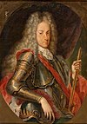 | 5 May 1705 - 17 Apr 1711 József I  (b. 1678 - d. 1711)
20 Sep 1705 - 21 Feb 1711 Ferenc Lipót Rákóczi de
felsövadászi (in dissidence)
(Magyarország vezérlő fejedelme)
(b. 1676 - d. 1735)
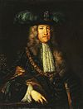 | 17 Apr 1711 - 20 Oct 1740 Károly III  (b. 1685 - d. 1740)
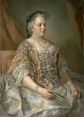 | 20 Oct 1740 - 29 Nov 1780 Mária Terézia (f)  (b. 1717 - d. 1780)
House of Habsburg-Lorraine (1780–1918)
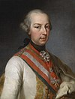 | 29 Nov 1780 - 20 Feb 1790 József II  (b. 1741 - d. 1790)
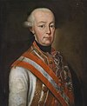 | 20 Feb 1790 - 1 Mar 1792 Lipót II  (b. 1747 - d. 1792)
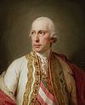 | 1 Mar 1792 - 28 Sep 1830 Ferenc I  (b. 1768 - d. 1835)
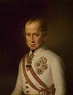 | 28 Sep 1830 - 2 Dec 1848 Ferdinánd V  (b. 1793 - d. 1875)
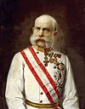 | 2 Dec 1848 - 14 Apr 1849 Ferenc József I (1st time)  (b. 1830 - d. 1916)
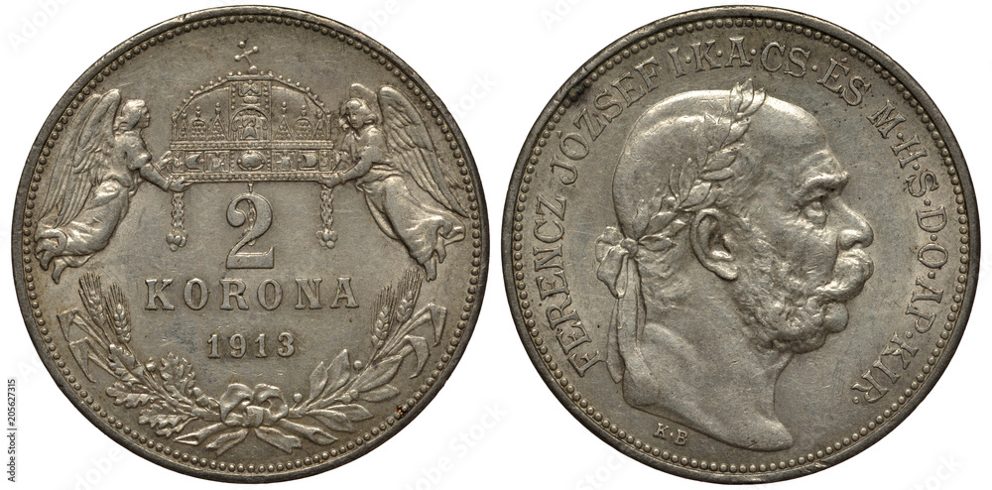
 |  | 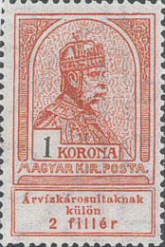
Governor-Presidents
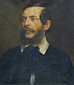 | 14 Apr 1849 - 11 Aug 1849 Lajos Kossuth  (b. 1802 - d. 1894)
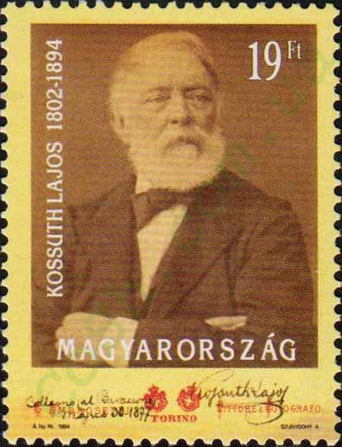
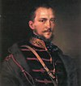 | 11 Aug 1849 - 13 Aug 1849 Artúr Görgey (acting)  (b. 1818 - d. 1916)
INCLUDEPICTURE "http://cosh.com.ua/img.php?cat=4&num=7509" \* MERGEFORMATINET 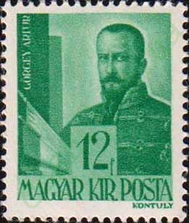
Kings
- Habsburg-Lotaringiai dynasty -
 | 13 Aug 1849 - 21 Nov 1916 Ferenc József I (2nd time) (s.a.)
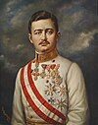 | 21 Nov 1916 - 13 Nov 1918 Károly IV  (b. 1887 - d. 1922) (king in dissidence 20-26 Oct 1921)
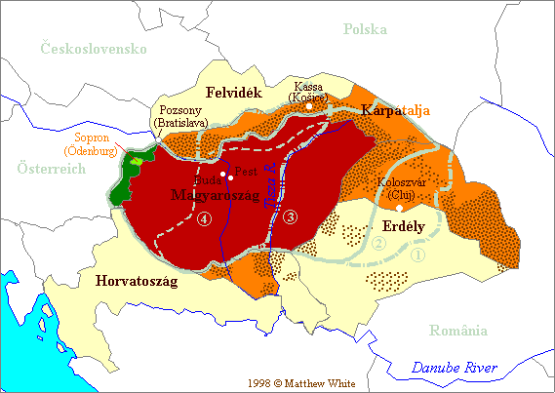
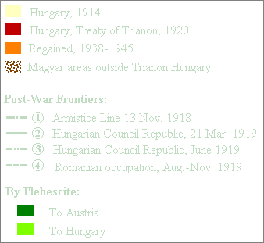
Chairman of the National Council
13 Nov 1918 - 16 Nov 1918 János Hock
(b. 1859 - d. 1936)
Provisional President
16 Nov 1918 - 21 Mar 1919 Mihály gróf Károlyi de Nagykároly
(b. 1875 - d. 1955) (acting to 11 Jan 1919)
Chairman of the Central Executive Committee
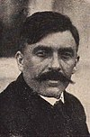 | 21 Mar 1919 - 1 Aug 1919 Sándor Garbai  (b. 1879 - d. 1947) (acting to 23 Jun 1919)
5 May 1919 - 12 Aug 1919 Governing Council
(counter-government in Arad and then in Szeged)
- Béla Fülöp (b. 1863 - d. 1938)
- Gyula Gömbös de Jákfa (b. 1886 - d. 1936)
- Károly Hencz (b. 1877 - d. 1949)
- Lajos Varjassy (b. 1852 - d. 1934)
Acting head of state
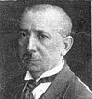 | 1 Aug 1919 - 6 Aug 1919 Gyula Peidl  (b. 1873 - d. 1943)
Governor (usually referred to as Regent)
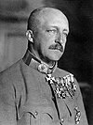 | 6 Aug 1919 - 23 Aug 1919 Archduke and Royal Duke József  (b. 1872 - d. 1962)
Acting heads of state
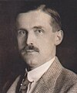 | 23 Aug 1919 - 24 Nov 1919 István Friedrich  (b. 1883 - d. 1951)
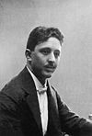 | 24 Nov 1919 - 1 Mar 1920 Károly Huszár  (b. 1882 - d. 1941)
Governor (always referred to as Regent)
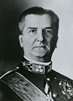 | 1 Mar 1920 - 3 Nov 1944 Miklós Horthy de Nagybánya  (b. 1868 - d. 1957)
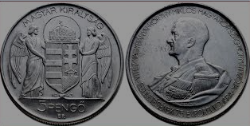
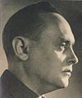
4 Nov 1944 - 28 Mar 1945 Governing (Regency) Council
- Károly Beregffy (b. 1878 - d. 1946)
- Ferenc Rajniss (b. 1893 - d. 1946)
- Sándor Csia (b. 1894 - d. 1946)
together with Ferenc Szálasi (b. 1897 - d. 1946)
(Leader of the Nation)
Chairmen of the Provisional National Assembly
21 Dec 1944 István Vásáry (provisional)
(b. 1887 - d. 1955)
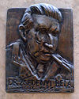 | 21 Dec 1944 - 26 Jan 1945 Béla Zsedényi  (b. 1894 - d. 1955)
26 Jan 1945 - 7 Dec 1945 High National Council
 | - Béla Zsedényi (s.a.)
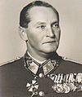 | - Béla Miklós de Dálnok (b. 1890 - d. 1948)
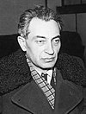 | - Ernö Gerö (to 11 May 1945) (s.a.)
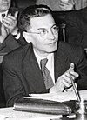 | - József Révai  (b. 1898 - d. 1959) (11 May - 27 Sep 1945)
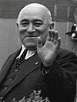 | - Mátyás Rákosi (s.a.) (from 27 Sep 1945)
7 Dec 1945 - 2 Feb 1946 High National Council
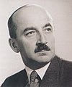 | - Ferenc Nagy  (b. 1903 - d. 1979)
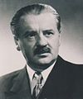 | - Zoltán Tildy  (b. 1889 - d. 1961)
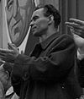 | - László Rajk  (b. 1909 - d. 1949)
- Béla Varga (to 8 Jan 1946)
(b. 1903 - d. 1995)
Presidents
 | 2 Feb 1946 - 3 Aug 1948 Zoltán Tildy (s.a.)
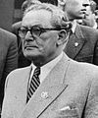 | 3 Aug 1948 - 23 Aug 1949 Árpád Szakasits  (b. 1888 - d. 1965)
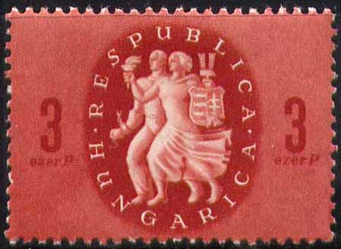
Chairmen of the Presidential Council
 | 23 Aug 1949 - 26 Apr 1950 Árpád Szakasits (s.a.)
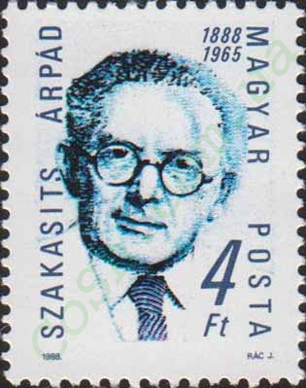
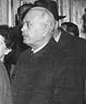 | 26 Apr 1950 - 14 Aug 1952 Sándor Rónai  (b. 1892 - d. 1965)
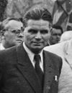 | 14 Aug 1952 - 14 Apr 1967 István Dobi  (b. 1898 - d. 1968)
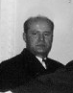 | 14 Apr 1967 - 25 Jun 1987 Pál Losonczi  (b. 1919 - d. 2005)
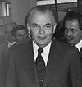 | 25 Jun 1987 - 29 Jun 1988 Károly Németh  (b. 1922 - d. 2008)
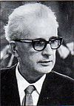 | 29 Jun 1988 - 23 Oct 1989 Brunó Ferenc Straub  (b. 1914 - d. 1996)
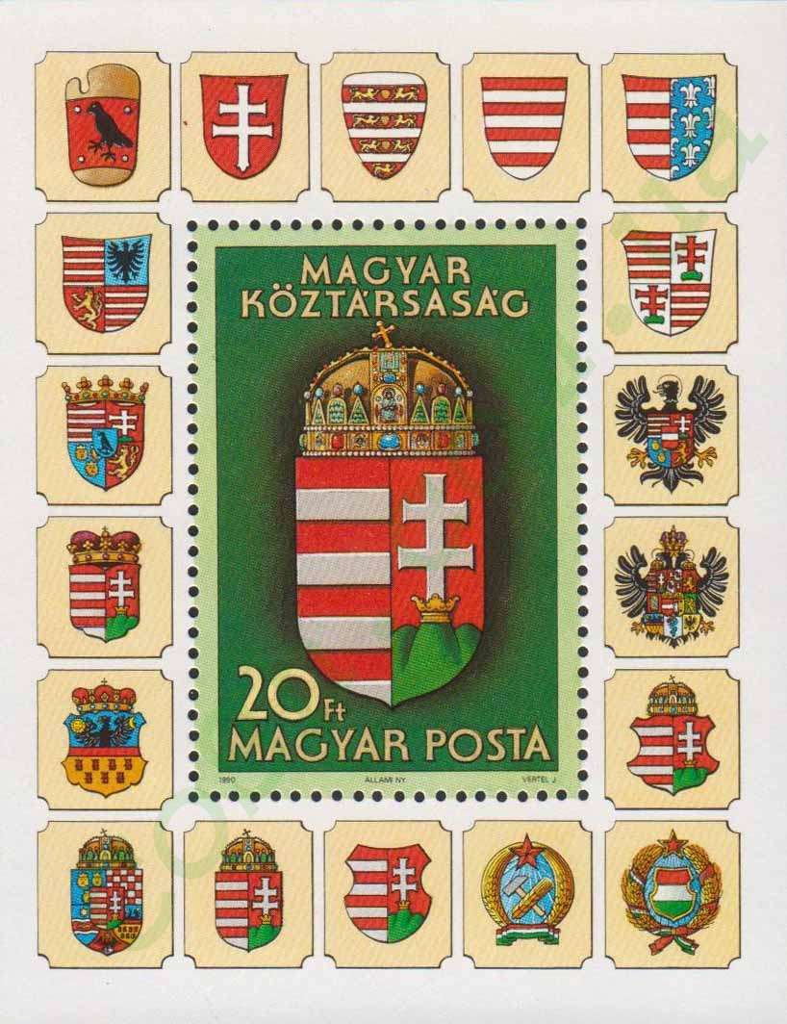
Presidents
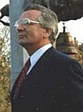 | 23 Oct 1989 - 2 May 1990 Mátyás Szürös (interim)  (b. 1933)
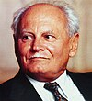 | 2 May 1990 - 4 Aug 2000 Árpád Göncz  (b. 1922 - d. 2015) (interim to 3 Aug 1990)
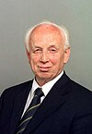 | 4 Aug 2000 - 5 Aug 2005 Ferenc Mádl  (b. 1931 - d. 2011)
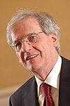 | 5 Aug 2005 - 6 Aug 2010 László Sólyom  (b. 1942)
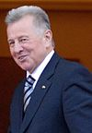 | 6 Aug 2010 - 2 Apr 2012 Pál Schmitt  (b. 1942)
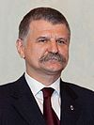 | 2 Apr 2012 - 10 May 2012 László Kövér (acting)  (b. 1959)
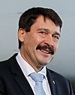 | 10 May 2012 - 10 May 2022 János Áder  (b. 1959)
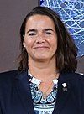 | 10 May 2022 - Katalin Novák (f)  (b. 1977)

Palatines²
c.1055 Sámuel Aba (s.a.)
c.1057 Zache (Zacha)
c.1066 Radó (d. 1057)
c.1067 Ottó nembeli Győr
1075 - 1091 Radvány (Rodoan) (d. af.1070)
1091 Gyula (1st time)
1094 Péter
1108 - 1113 Gyula (2nd time)
1131 - c.1138 János fia Uros
c.1141 Gyula (acting)
1146 - 1157 Fancsal fia Bozeta
1157 - c.1159 Gereon (acting)
1162 - 1163 Belus (Beloš Urošić) (s.a.)
1163 Henrik Héder (d. af.1163)
1165 - 1174 Tamás (1st time)
1174 - 1177 Lőrinc (acting)
1177 - 1183 Ampud
1184 Farkas nembeli Bikács
1185 - 1186 Dénes
1188 - 1192 Mog (Moch) (1st time) (acting)
1192 - 1193 Tamás (2nd time)
1197 - 1198 Mog (2nd time)
1198 - 1199 Ézsau
1199 - 1201 Mog (3rd time)
1202 - 1204 Mika (Mihály) nembeli Ják
1205 Benedek
1205 - 1206 Gyula (acting)
1206 Miklós
1206 - 1209 Mog (4th time)
1209 - 1212 Csépán nembeli Győr
1212 - 1213 Pot nembeli Győr
1213 - 1214 Bánk nembeli Bór-Kalán (d. af.1228)
1215 - 1217 Miklós nembeli Szák (1st time)
1219 - 1222 Gyula nembeli Kán (1st time) (s.a.)
1222 Miklós nembeli Szák (2nd time)
1222 - 1226 Tódor nembeli Csanád (d. c.1234)
1226 Gyula nembeli Kán (2nd time) (s.a.)
1227 - 1228 Miklós nembeli Szák (3rd time)
1229 - 1230 Dénes fia Dénes nembeli Tomaj (1st time) (b. 11.. - d. 1241)
1231 - 1234 Mojs
1234 - 1235 Benedek fia Samud (acting)
1235 - 11 Apr 1241 Dénes fia Dénes nembeli Tomaj (2nd time) (s.a.)
1241 - 1242 Arnold fia Arnold nembeli Hahót (b. 11.. - d. af.1244)
1242 - 1245 László nembeli Kaán
1245 - Jul? 1246 Dénes nembeli Türje (1st time) (d. 1255)
Jul? 1246 - Apr 1248 István fia Dragun nembeli Gut-Keled(b. 12.. - d. 1259)
Apr 1248 - 1. Sep 1248 Dénes nembeli Türje (2nd time) (s.a.)
1. Sep 1248 - Aug 1261 Loránd fia Domokos nembeli Rátót (1st time) (b. 12.. - d. 1277?)
Aug 1261 - Jan? 1267 Henrik Kőszegi fia Henrik nembeli Héder (b. 12.. - d. 1274)
Jan? 1267 - 1. May 1270 Lőrinc fia Kemény (1st time) (b. 12.. - d. af.1273)
1. May 1270 - Jun 1272 Mojs (Mois) fia Mojs (Mois) (b. 12.. - d. 1280)
Jun 1272 - 27 Nov 1272 Lőrinc fia Kemény (2nd time) (s.a.)
27 Nov 1272 - Nov 1273 Loránd fia Domokos nembeli Rátót (2nd time) (s.a.)
Nov 1273 - 27 Sep 1274 Dénes fia György nembeli Pécz (1st time) (b. 12.. - d. 1284?)
27 Sep 1274 - Jun 1275 Loránd fia Domokos nembeli Rátót (s.a.)
Jun 1275 - Nov? 1275 Miklós Kőszegi fia Henrik nembeli Héder
(1st time) (b. 12.. - d. 1299)
Nov? 1275 - Jun 1276 Péter fia Máté nembeli Csák (1st time) (b. 12.. - d. c.1280)
Jun 1276 - Jul 1277 Miklós Kőszegi fia Henrik nembeli Héder (2nd time) (s.a.)
Jul 1277 - Nov 1277 Péter fia Máté nembeli Csák (2nd time) (s.a.)
Nov 1277 - Mar 1278 Dénes fia György nembeli Pécz (2nd time) (s.a.)
Mar 1278 - Jun 1278 Péter fia Máté nembeli Csák (3rd time) (s.a.)
Jun 1278 - Jul 1280 Máté fia Máté nembeli Csák (b. 12.. - d. 1283)
Jul 1280 - Apr 1281 Finta fia Dávid nembeli Aba (b. 12.. - d. 1287)
Apr 1281 - Aug 1282 Iván Kőszegi fia Henrik nembeli Héder (1st time)
(b. 12.. - d. 1308)
Aug 1282 - Oct 1286 Miklós Kőszegi fia Henrik Héder (1st time) (b. 12.. - d. 1299)
Oct 1286 - Jul 1287 Makján (Mokianus) fia Büken nembeli Aba
Jul 1287 - Aug 1288 Iván Kőszegi fia Henrik nembeli Héder (2nd time) (s.a.)
Aug 1288 - Aug 1289 Amadé (Omode) fia Dávid nemzetségi Aba (1st time) (s.a.)
Aug 1289 - 1290 Rénold fia Rénold nembeli Básztély (b. 12.. - d. c.1296)
Sep 1289 - 20 Jun 1290 Miklós Kőszegi fia Henrik Héder (2nd time) (s.a.)
20 Jun 1290 - 2. Jul 1290 Mizse
2. Jul 1290 - Feb 1291 Amadé fia Dávid nembeli Aba (2nd time) (s.a.)
Feb 1291 - Nov 1291 Miklós Kőszegi fia Henrik nembeli Héder (3rd time) (s.a.)
Nov 1291 - 1293 Mihály nembeli Szente-Mágocs
1293 - Nov 1293 Amadé fia Dávid nembeli Aba (3rd time) (s.a.)
Nov 1293 - Nov 1295 Miklós Kőszegi fia Henrik nembeli Héder (4th time) (s.a.)
Nov 1295 - Nov? 1296 Amadé fia Dávid nembeli Aba (4th time) (s.a.)
Nov? 1296 - Oct 1297 Máté fia Péter nembeli Csák (1st time) (s.a.)
Oct 1297 - Oct? 1298 Amadé fia Dávid nembeli Aba (5th time) (s.a.)
Oct? 1298 - Aug 1299 Apor fia Márk nembeli Pécz (b. 12.. - d. af.1307)
+ Loránd fia Lesuták nembeli Rátót (s.a.)
Aug 1299 - 1301 Amadé fia Dávid nembeli Aba (6th time) (s.a.)
1301 - 1302 Máté fia Péter nembeli Csák (2nd time) (s.a.)
1302 - Jun 1303 István fia Erne nembeli Ákos (1st time) (s.a.)
Jun 1303 - Apr 1304 Iván Kőszegi fia Henrik nembeli Héder (1st time)
(b. 12.. - d. 1308)
Apr 1304 - 1305 István fia Erne nembeli Ákos (2nd time) (s.a.)
1305 - Feb? 1306 Jakab Kopasz fia Tamás nembeli Borsa (s.a.)
Feb? 1306 - Jun 1307 Iván Kőszegi fia Henrik nembeli Héder (2nd time) (s.a.)
Jun 1307 - Jun 1310 Máté fia Péter nembeli Csák (3rd time) (s.a.)
Jun 1307 - Jun 1310 Amadé fia Dávid nemzetségi Aba (7th time) (s.a.)
Jun 1307 - 1315 Jakab Kopasz fia Tamás nembeli Borsa (s.a.)
1315 - 1320 Domokos fia István Porch nembeli Rátót (b. 12.. - d. af.1320)
1321 - Aug 1322 Dózsa Debreceni (b. 12.. - d. 1322)
c.Sep 1322 - Sep 1327 Fülöp Drugeth (b. c.1288 - d. 1327)
Sep 1327 - Feb 1328 Sándor Köcski (acting) (b. 12.. - d. 1328)
Feb 1328 - Sep 1328 Pál Nagymartoni (1st time)(acting) (b. 128. - d. c.1350)
Sep 1328 - Jun 1333 János Drugeth homonnai (b. 129. - d. 1334)
Jun 1333 - Jul 1333 Pál Nagymartoni (2nd time)(acting) (s.a.)
Jul 1333 - Aug 1342 Vilmos Drugeth homonnai (b. 131. - d. 1342)
Aug 1342 - Oct 1342 Pál Nagymartoni (3rd time)(acting) (s.a.)
Oct 1342 - Mar 1356 Miklós Gilétfi (b. 129. - d. 1356?)
Mar 1356 - Mar 1356 Miklós Szécsi felsőlendvai (1st time) (acting)
(b. 131. - d. 1387)
Mar 1356 - Apr 1367 Miklós Kont Újlaki (b. 131. - d. 1367)
Apr 1367 - 2. Apr 1367 István Bebek pelsőci (acting) (b. 131. - d. 1369)
2. Apr 1367 - Oct 1372 László herceg Oppelni
(= Władisław książę Opolski) (b. 133. - d. 1401)
Oct 1372 - May 1375 Imre Lackfi kerekegyházi (b. 133. - d. 1375)
May 1375 - Jul? 1375 Jakab Szepesi (acting) (b. 133. - d. 1380)
Jul? 1375 - Sep 1385 Miklós Garai (s.a.)
Sep 1385 - Oct 1386 Miklós Szécsi felsőlendvai (2nd time) (s.a.)
Oct 1386 - Nov 1392 István Lackfi csáktornyai (b. 133. - d. 1397)
Nov 1392 - Jun 1397 Leusták Jolsvai
(Ottoman prisoner from 28 Sep 1696) (b. 133. - d. 1405)
28 Sep 1396 - Jun 1397 János Pásztói (acting) (b. 134. - d. 1406?)
Jun 1397 - 2. Sep 1402 Detre Bebek vámosi (b. 135. - d. 1404)
2. Sep 1402 - Dec 1433 Miklós Garai (b. c.1367 - d. 1433)
Dec 1433 - Dec 1433 Máté Pálóczi (Pálóci) (1st time) (acting) (b. 138. - d. 1437)
Dec 1433 - 8? Mar 1435 György Pálóczi, érsek Esztergomi (b. 138. - d. 1439)
8? Mar 1435 - 2. Dec 1436 Máté Pálóczi (2nd time) (s.a.)
2. Dec 1436 - 7 Mar 1437 István Báthori (acting) (b. 139. - d. 1444)
7 Mar 1437 - Jul 1447 Lőrinc Hédervári (s.a.)
Aug 1447 - 15 Sep 1447 László Pálóczi (Pálóci)(acting) (b. 140. - d. 1470)
15 Sep 1447 - 27 Jul 1458 László Garai (s.a.)
27 Jul 1458 - 11 Nov 1484 Mihály Orságh (Ország) guthi (b. 141. - d. 1484)
11 Nov 1484 - Jan 1486 István Báthori ecsedi (1st time) (acting) (b. 1430 - d. 1493)
Jan 1486 - 12 Sep 1487 Imre gróf Szápolyai (Zápolyai) szepesi (b. 141. - d. 1487)
12 Sep 1487 - 5 Dec 1487 István Báthori ecsedi (2nd time) (acting) (s.a.)
5 Dec 1487 - 21 Oct 1491 Orbán Dóczi Nagylucsei, püspök Egri(b. 143. - d. 1491)
21 Oct 1491 - 29 Mar 1492 István Báthori ecsedi (3rd time) (acting) (s.a.)
29 Mar 1492 - 25 Dec 1499 István gróf Szápolyai (Zápolyai) szepesi (b. 143. - d. 1499)
25 Dec 1499 - 22 Feb 1503 Péter Geréb Vingárti (von Wyngarth)
(acting to 1 Feb 1500) (b. 144. - d. 1503)
22 Feb 1503 - 24 Apr 1504 Péter gróf Szentgyörgyi és Bazini(acting) (b. 146. - d. 1517)
24 Apr 1504 - 5 Feb 1519 Imre fejedelem Perényi siklósi (b. 146. - d. 1519)
5 Feb 1519 - 28 May 1519 Lőrinc Újlaki (acting) (b. c.1459 - d. 1524)
Royal Governors
18 May 1519 - 5 Jul 1525 István Báthory ecsedi (1st time) (b. 147. - d. 1530)
5 Jul 1525 - 28 Apr 1526 István Verbőczy (Werbőczy) (b. c.1458 - d. 1541)
28 Apr 1526 - 14 Feb 1530 István Báthory ecsedi (2nd time) (s.a.)
3 Feb 1527 - 20 Aug 1527 Mária (f) (= Maria von Österreich) (in dissidence)
(b. 1505 - d. 1558)
14 Feb 1530 - 30 Jan 1534 János Bánffy alsólindvai (b. 147. - d. 1534)
4 Oct 1532 - 12 Nov 1542 Elek báró Thurzó bethlenfalvi
(in dissidence in Gran to 22 Jul 1540) (b. 1490 - d. 1543)
12 Nov 1542 - 26 Nov 1542 Tamás báró Nádasdy nádasdi és fogarasföldi (acting)
(b. 1498 - d. 1562)
26 Nov 1542 - 30 Dec 1542 Ferenc Révay szklabinai és
blatniczai (1st time) (acting) (b. 1489 - d. 1553)
30 Dec 1542 - 12 Oct 1549 Pál Várdai kisvárdai (b. 1481 - d. 1549)
12 Oct 1549 - 12 Apr 1550 Ferenc Révay szklabinai és
blatniczai (2nd time) (acting) (s.a.)
12 Apr 1550 - 13 Mar 1554 Ferenc Újlaky (b. 1485 - d. 1555)
Palatines²
13 Mar 1554 - 2 Jun 1562 Tamás gróf Nádasdy nádasdi és fogarasföldi
(b. 1498 - d. 1562)
2 Jun 1562 - 25 Sep 1562 András Báthori ecsedi (acting) (b. 150. - d. 1566)
Royal Governors
25 Sep 1562 - 14 Jan 1568 Miklós Oláh (Nekulae Olah) (b. 1493 - d. 1568)
14 Jan 1568 - 9 Apr 1568 Mihály báró Mérey kapos-mérei (acting)
(b. 1500 - d. 1572)
9 Apr 1568 - 24 Jun 1572 Pál Bornemissza (b. 1499 - d. 1579)
24 Jun 1572 - 15 Jun 1573 Antal Verántz (Ante Verančić) (b. 1504 - d. 1573)
15 Jun 1573 - 1 Sep 1573 Imre báró Czobor czoborszentmihályi (acting)
(b. 151. - d. 1581)
1 Sep 1573 - 4 Feb 1586 István Radéczi zemchei (b. 151. - d. 1586)
4 Feb 1586 - 24 Sep 1586 Miklós Istvánffy baranyavári
és kiasszonyfalvi (1st time)(acting) (b. 1538 - d. 1615)
24 Sep 1586 - 31 Jan 1587 György Draskovich trakostyáni (Juraj Drašković)
(b. 1515 - d. 1587)
31 Jan 1587 - 13 Aug 1587 Miklós báró Istvánffy baranyavári
és kiasszonyfalvi (2nd time) (acting) (s.a.)
13 Aug 1587 - 20 Nov 1596 István Fejérkövy (Fehérkövy) (b. 1522 - d. 1596)
20 Nov 1596 - 2 Jun 1597 Miklós báró Istvánffy baranyavári
és kiasszonyfalvi (3rd time) (acting) (s.a.)
2 Jun 1597 - 16 Sep 1601 János Kutassy (Kutasi) (b. c.1545 - d. 1601)
16 Sep 1601 - 8 Feb 1602 Miklós báró Istvánffy baranyavári
és kiasszonyfalvi (4th time)(acting) (s.a.)
8 Feb 1602 - 5 Oct 1605 Márton Pethe hethesi (b. 1552 - d. 1605)
5 Oct 1605 - 4 Jul 1607 Miklós báró Istvánffy baranyavári
és kiasszonyfalvi (5th time)(acting) (s.a.)
4 Jul 1607 - 19 Nov 1608 Ferenc gróf Forgách ghymesi és gácsi
(b. 1566 - d. 1615)
Palatines²
20 Nov 1608 - 5 May 1609 István báró Illyesházy illésházai (b. 1541 - d. 1609)
5 May 1609 - 7 Nov 1609 Bálint Drugeth gereni és homonnai
(acting) (b. 1577 - d. 1609)
7 Nov 1609 - 10 Dec 1609 Zsigmond báró Forgách ghymesi és
gácsi (1st time) (acting) (b. 155. - d. 1621)
10 Dec 1609 - 24 Dec 1616 György gróf Thurzó bethlenfalvi (b. 1567 - d. 1616)
24 Dec 1616 - 30 Jun 1621 Zsigmond báró Forgách ghymesi és
gácsi (2nd time)(acting to 11 May 1618) (s.a.)
30 Jun 1621 - 16 May 1622 Tamás gróf Erdődy monyorókeréki
és monoszlói (acting) (b. 1558 - d. 1624)
16 May 1622 - 1 May 1625 Sztaniszló gróf Thurzó bethlenfalvi(b. 1576 - d. 1625)
1 May 1625 - 11 Sep 1645 Miklós báró Esterházy galánthai
(acting to 25 Oct 1645) (b. 1582 - d. 1645)
11 Sep 1645 - 22 Nov 1645 János gróf Drugeth homonnai (acting) (b. 1609 - d. 1645)
22 Nov 1645 - 6 Feb 1646 István gróf Csáky körösszeghi és
adorjáni (acting) (b. 1603 - d. 1662)
6 Feb 1646 - 25 Sep 1646 Pál gróf Pálffy erdődi (1st time)
(acting) (b. 1590 - d. 1653)
25 Sep 1646 - 5 Aug 1648 János gróf Draskovich trakostyáni
(Ivan Drašković) (b. 1595 - d. 1648)
5 Aug 1648 - 26 Nov 1653 Pál gróf Pálffy erdődi (2nd time) (acting to 24 Mar 1649) (s.a.)
26 Nov 1653 - 14 Oct 1654 László gróf Csáky körösszeghi és
adorjáni (acting) (b. 159. - d. 1655)
14 Oct 1654 - 15 Mar 1655 István gróf Csáky körösszeghi és
adorjáni (acting) (b. 1603 - d. 1662)
15 Mar 1655 - 23 Mar 1667 Ferenc gróf Wesselényi hadadi és
murányi (b. 1605 - d. 1667)
23 Mar 1667 - 3 Sep 1670 Ferenc gróf Nádasdy nádasdi
(royal governor) (b. 1622 - d. 1671)
3 Sep 1670 - 18 Oct 1670 Ádám gróf Forgách ghymesi és gácsi
(acting royal governor) (b. 1601 - d. 1681)
18 Oct 1670 - 13 Jun 1681 György Szelepcsényi pohronczi
(royal governor) (b. 1595 - d. 1685)
13 Jun 1681 - 26 Mar 1713 Pál herceg Esterházy galánthai
(from 8 Dec 1687, Pál fejedelem Esterházy galánthai) (b. 1635 - d. 1713)
26 Mar 1713 - 20 Mar 1732 Miklós gróf Pálffy erdődi
(acting to 15 Oct 1714) (b. 1657 - d. 1732)
20 Mar 1732 - 5 Apr 1732 János gróf Pálffy erdődi (1st time)(b.
(acting) 1664 - d. 1751)
5 Apr 1732 - 22 Jun 1741 Franz Stephan Herzog von
Lothringen und Bar (royal governor) (b. 1708 - d. 1765)
22 Jun 1741 - 24 Mar 1751 János gróf Pálffy erdődi (2nd time)(s.a.)
24 Mar 1751 - 11 May 1751 György gróf Erdődy monyorókeréki
és monoszlói (acting) (b. 1676 - d. 1759)
11 May 1751 - 26 Oct 1765 Ludwig Ernst gróf Batthyány
németújvári(b. 1696 - d. 1765)
26 Oct 1765 - 26 Dec 1765 Miklós gróf Pálffy erdődi (acting) (b. 1710 - d. 1773)
26 Dec 1765 - 1780 Albert Kasimir August von Sachsen
Herzog zu Teschen (royal governor) (b. 1738 - d. 1822)
Presidents of the Government Council
1780 - 14 Aug 1783 György gróf Fekete galánthai (b. 1711 - d. 1788)
14 Aug 1783 - 21 Dec 1786 János gróf Csáky körösszeghi és (b. 1720 - d. 1795)
adorjáni
21 Dec 1786 - 26 Dec 1787 Kristóf gróf Niczky niczki (b. 1725 - d. 1787)
26 Dec 1787 - 18 Dec 1788 Antal Jankovich pribéri (acting) (b. 1730 - d. 1789)
18 Dec 1788 - 12 Nov 1790 Károly Zichy zichi és vásonykeői (b. 1753 - d. 1826)
Palatines²
12 Nov 1790 - 12 Jul 1795 Alexander Leopold Erzherzog
von Österreich (b. 1772 - d. 1795)
12 Jul 1795 - 20 Jul 1795 Péter Végh verebi (acting) (b. 1725 - d. 1802)
30 Jul 1795 - 13 Jan 1847 Joseph Anton Johann Erzherzog
von Österreich (royal governor to 12 Nov 1795) (b. 1776 - d. 1847)
13 Jan 1847 - 12 Nov 1847 György Mailáth székhelyi (1st time)
(acting) (b. 1818 - d. 1883)
12 Nov 1847 - 25 Sep 1848 Stephan Franz Erzherzog von
Österreich (b. 1817 - d. 1867)
25 Sep 1848 - 14 Apr 1849 György Mailáth székhelyi (acting) (2nd time)(s.a.)
President of the Council of Ministers (Prime minister)
17 Mar 1848 - 8 Oct 1848 Lajos gróf Batthyányi németújvári (b. 1807 - d. 1849) EP
President of the Committee of National Defense
8 Oct 1848 - 14 Apr 1849 Lajos Kossuth udvardi és
kossutfalvai (in rebellion from 1 Jan 1849 in Debrecen) , EP (s.a.)
President of the Council of Ministers (Prime minister)
2 May 1849 - 11 Aug 1849 Bertalan Szemere szemerei (in rebellion, in Debrecen)
(b. 1812 - d. 1869) EP
Austrian Army High Commanders
5 Jan 1849 - 12 Apr 1849 Alfred Candidus Ferdinand Fürst zu
Windischgrätz Mil (b. 1787 - d. 1862)
12 Apr 1849 - 30 May 1849 Franz Ludwig Freiherr von Welden Mil (b. 1782 - d. 1853)
30 May 1849 - 8 Jul 1850 Julius Freiherr von Haynau
(from 24 Oct 1849, commander of the Austrian
Imperial Army in Hungary and Transylvania) Mil (b. 1786 - d. 1853)
Imperial Commissioner for the Civil Administration
4 Jun 1849 - 12 Sep 1851 Carl Gabriel Freiherr von Geringer
-Oedenberg Non-party (b. 1806 - d. 1889)
Austrian Military and Civil Governors
8 Jul 1850 - 10 Oct 1851 Carl Gabriel Freiherr von Geringer
-Oedenberg (acting) Non-party (s.a.)
10 Oct 1851 - 20 Apr 1860 Albrecht Friedrich Rudolf
Erzherzog von Österreich Mil(b. 1817 - d. 1865)
20 Apr 1860 - 20 Oct 1860 Ludwig August Ritter von Benedek
(acting) Mil (b. 1804 - d. 1881)
Chairman of the Governing Council
20 Oct 1860 - 5 Nov 1861 György Mailáth székhelyi Non-party Governor (s.a.)
6 Nov 1861 - 18 Jul 1865 Móric gróf Pállfy erdődi Mil (b. 1812 - d. 1897)
Chairman of the Governing Council
18 Jul 1865 - 12 Jun 1867 Pál báró Sennyey kis-sennyey Non-party (b. 1824 - d. 1888)
Royal Chancellors
20 Oct 1860 - 18 Jul 1861 Miklos báró Vay vajai és luskodi (b. 1802 - d. 1894) Non-party
18 Jul 1861 - 22 Apr 1864 Antal gróf Forgách ghymesi és gácsi Non-party
(b. 1819 - d. 1885)
22 Apr 1864 - 26 Jun 1865 Armin gróf Zichy zichi és vásonykeői Non-party
(b. 1814 - d. 1880)
26 Jun 1865 - 10 Mar 1867 Gyö
Prime ministers¹
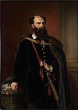 | 17 Mar 1848 - 2 Oct 1848 Lajos gróf Batthyány de Nemetujvár  (b. 1807 - d. 1849)
26 Nov 1848 - 11 Aug 1849 Lajos Kossuth (s.a.)
(acting to 14 Apr 1849)
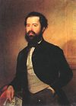 | 11 Aug 1849 - 13 Aug 1849 Bertalan Szemere de Szemere  (b. 1812 - d. 1869)
Chancellors
20 Oct 1860 - 18 Jul 1861 Miklos báró Vay de Vaja et Luskod
(b. 1802 - d. 1894)
 | 18 Jul 1861 - 22 Apr 1864 Antal gróf Forgách de Ghymes et Gács (b. 1819 - d. 1885)
 | 22 Apr 1864 - 27 Jul 1865 Ármin gróf Zichy de Zich et Vásonkeö (b. 1814 - d. 1880)
27 Jul 1865 - 17 Feb 1867 György Mailáth de Székhely
(b. 1818 - d. 1883)
Prime ministers¹
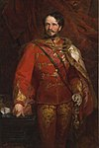 | 17 Feb 1867 - 14 Nov 1871 Gyula gróf Andrássy de Csíkszentkirály (b. 1823 - d. 1890)
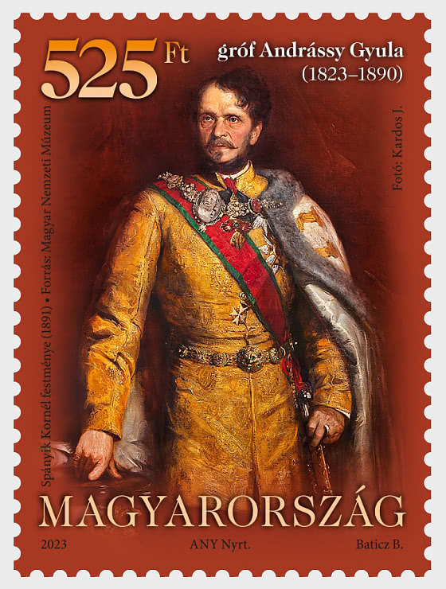
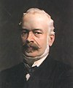 | 14 Nov 1871 - 4 Dec 1872 Menyhért gróf Lónyay de Nagylónya  et Vásárosnamény (b. 1822 - d. 1884)
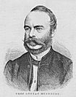
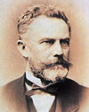 | 4 Dec 1872 - 1 Mar 1874 József Szlávy de Érkenéz et Okány  (b. 1818 - d. 1900)
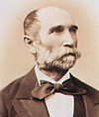 | 1 Mar 1874 - 2 Mar 1875 István Bittó de Sárosfalva  (b. 1822 - d. 1903)
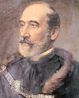 | 2 Mar 1875 - 20 Oct 1875 Béla báró Wenckheim  (b. 1811 - d. 1879)
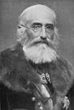 | 20 Oct 1875 - 13 Mar 1890 Kálmán Tisza de Borosjenö et Szeged  (b. 1830 - d. 1902)
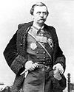 | 13 Mar 1890 - 17 Nov 1892 Gyula gróf Szapáry de Szapár  (b. 1832 - d. 1905)
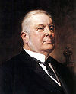 | 17 Nov 1892 - 1 Jan 1895 Sándor Wekerle (1st time)  (b. 1848 - d. 1921)
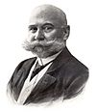 | 14 Jan 1895 - 26 Feb 1899 Dezsö báró Bánffy de Losoncz  (b. 1843 - d. 1911)
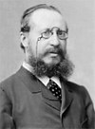 | 26 Feb 1899 - 27 Jun 1903 Kálmán Széll de Duka et  Szentgyörgyvölgy (b. 1845 - d. 1915)
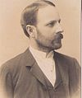 | 27 Jun 1903 - 3 Nov 1903 Károly gróf Khuen-Héderváry de  Hédervár (1st time) (b. 1849 - d. 1918)
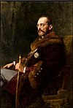 | 3 Nov 1903 - 18 Jun 1905 István gróf Tisza de Borosjenö  et Szeged (1st time) (b. 1861 - d. 1918)
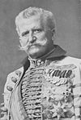 | 18 Jun 1905 - 8 Apr 1906 Géza báró Fejérváry de  Komlós-Keresztes (b. 1833 - d. 1914)
8 Apr 1906 - 17 Jan 1910 Sándor Wekerle
(2nd time) (s.a.)
17 Jan 1910 - 22 Apr 1912 Károly gróf Khuen-Héderváry de
Hédervár (2nd time) (s.a.)
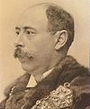 | 22 Apr 1912 - 10 Jun 1913 László Lukács  (b. 1850 - d. 1932)
10 Jun 1913 - 15 Jun 1917 István gróf Tisza de Borosjenö
et Szeged (2nd time) (s.a.)
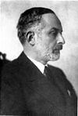 | 15 Jun 1917 - 20 Aug 1917 Móric gróf Esterházy de Galántha  (b. 1881 - d. 1960)
20 Aug 1917 - 30 Oct 1918 Sándor Wekerle
(3rd time) (s.a.)
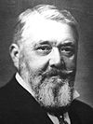 | 30 Oct 1918 - 31 Oct 1918 János gróf Hadik de Futak  (b. 1863 - d. 1933)
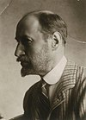 | 31 Oct 1918 - 11 Jan 1919 Mihály gróf Károlyi de Nagykároly (s.a.)
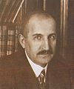 | 18 Jan 1919 - 22 Mar 1919 Dénes Berinkey  (b. 1871 - d. 1944)
Chairmen of the Revolutionary Government Council
 | 22 Mar 1919 - 23 Jun 1919 Sándor Garbai (s.a.)
5 May 1919 - 12 Jul 1919 Gyula gróf Károlyi de Nagykároly
(b. 1871 - d. 1947)
(prime minister of counter-government, in Arad
to 30 May 1919, then in Szeged)
24 Jun 1919 - 1 Aug 1919 Antal Dovcsák
(b. 1879 - d. 1962)
12 Jul 1919 - 12 Aug 1919 Dezsö Pattantyús-Ábrahám
(b. 1875 - d. 1977)
(prime minister of counter-government, in Szeged)
Prime ministers¹
 | 1 Aug 1919 - 6 Aug 1919 Gyula Peidl (s.a.)
 | 7 Aug 1919 - 24 Nov 1919 István Friedrich (s.a.)
 | 24 Nov 1919 - 14 Mar 1920 Károly Huszár (s.a.)
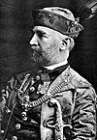 | 14 Mar 1920 - 19 Jul 1920 Sándor Simonyi-Semadam  (b. 1864 - d. 1946)
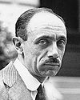 | 19 Jul 1920 - 14 Apr 1921 Pál gróf Teleki de Szék  (1st time) (b. 1879 - d. 1941)
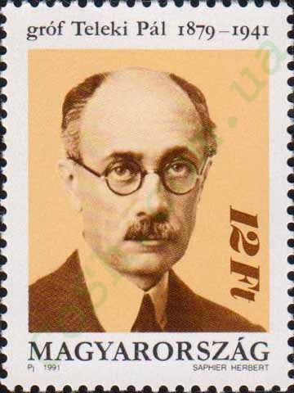
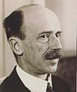 | 14 Apr 1921 - 19 Aug 1931 István gróf Bethlen de Bethlen  (b. 1874 - d. 1946)
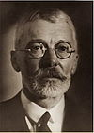 | 19 Aug 1931 - 4 Oct 1932 Gyula gróf Károlyi de Nagykároly (s.a.)
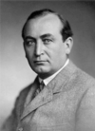 | 4 Oct 1932 - 6 Oct 1936 Gyula vitéz Gömbös de Jákfa (s.a.)
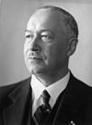 | 2 Nov 1936 - 14 May 1938 Kálmán Darányi  (b. 1886 - d. 1939)
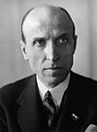 | 14 May 1938 - 16 Feb 1939 Béla Imrédy  (b. 1891 - d. 1946)
16 Feb 1939 - 3 Apr 1941 Pál gróf Teleki de Szék
(2nd time) (s.a.)
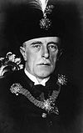 | 3 Apr 1941 Ferenc vitéz Keresztes-Fischer  (1st time) (acting) (b. 1881 - d. 1948)
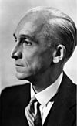 | 3 Apr 1941 - 7 Mar 1942 László Bárdossy  (b. 1890 - d. 1946)
7 Mar 1942 - 10 Mar 1942 Ferenc vitéz Keresztes-Fischer
(2nd time) (acting) (s.a.)
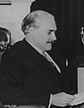 | 10 Mar 1942 - 23 Mar 1944 Miklós Kállay de Nagy-Kálló  (b. 1887 - d. 1967)
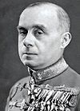 | 23 Mar 1944 - 29 Aug 1944 Döme Sztójay  (b. 1883 - d. 1946)
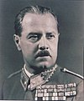 | 29 Aug 1944 - 16 Oct 1944 Géza vitéz Lakatos  (b. 1890 - d. 1967)
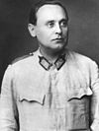 | 16 Oct 1944 - 28 Mar 1945 Ferenc Szálasi (s.a.)
22 Dec 1944 - 15 Nov 1945 Béla Miklós de Dálnok (acting) (s.a.)
(at Debrecen to 13 Feb 1945)
 | 15 Nov 1945 - 1 Feb 1946 Zoltán Tildy (s.a.)
1 Feb 1946 - 4 Feb 1946 Mátyás Rákosi
(1st time) (acting) (s.a.)
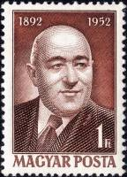
 | 4 Feb 1946 - 31 May 1947 Ferenc Nagy (s.a.)
 | 31 May 1947 Mátyás Rákosi (2nd time) (acting) (s.a.)
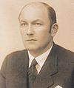 | 31 May 1947 - 10 Dec 1948 Lajos Dinnyés  (b. 1901 - d. 1961) (acting 4-24 Nov 1948)
10 Dec 1948 - 14 Aug 1952 István Dobi (s.a.)
(acting 20 May - 10 Jun 1949)
 | 14 Aug 1952 - 4 Jul 1953 Mátyás Rákosi (3rd time) (s.a.)
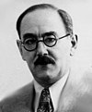 | 4 Jul 1953 - 18 Apr 1955 Imre Nagy (1st time)  (b. 1896 - d. 1958)
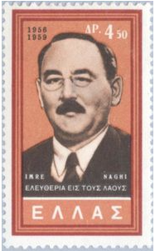
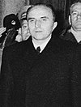 | 18 Apr 1955 - 24 Oct 1956 András Hegedüs  (b. 1922 - d. 1999)
24 Oct 1956 - 4 Nov 1956 Imre Nagy
(2nd time) (s.a.)
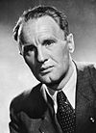 | 4 Nov 1956 - 28 Jan 1958 János Kádár (1st time) (s.a.)
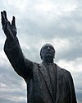 | 28 Jan 1958 - 13 Sep 1961 Ferenc Münnich  (b. 1886 - d. 1967)
INCLUDEPICTURE "http://cosh.com.ua/img.php?cat=4&num=20047" \* MERGEFORMATINET 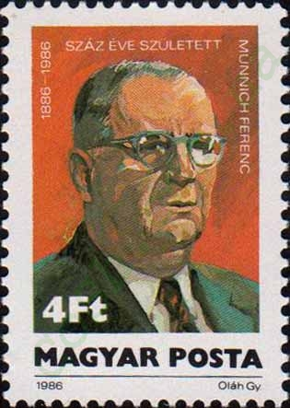
 | 13 Sep 1961 - 28 Jun 1965 János Kádár (2nd time) (s.a.)
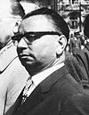 | 28 Jun 1965 - 14 Apr 1967 Gyula Kállai  (b. 1910 - d. 1996)
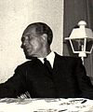 | 14 Apr 1967 - 15 May 1975 Jenö Fock  (b. 1916 - d. 2001)
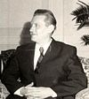 | 15 May 1975 - 25 Jun 1987 György Lázár  (b. 1924 - d. 2014)
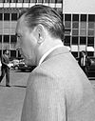 | 25 Jun 1987 - 23 Nov 1988 Károly Grósz (s.a.)
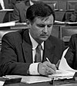 | 23 Nov 1988 - 23 May 1990 Miklós Németh  (b. 1948)
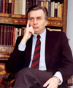 | 23 May 1990 - 12 Dec 1993 József Antall  (b. 1932 - d. 1993)
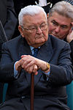 | 12 Dec 1993 - 15 Jul 1994 Péter Boross  (b. 1928) (acting to 21 Dec 1993)
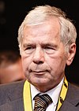 | 15 Jul 1994 - 6 Jul 1998 Gyula Horn  (b. 1932 - d. 2013)
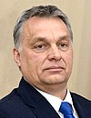 | 6 Jul 1998 - 27 May 2002 Viktor Orbán (1st time)  (b. 1963)
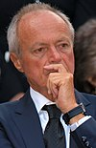 | 27 May 2002 - 29 Sep 2004 Péter Medgyessy  (b. 1942)
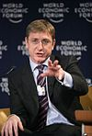 | 27 Aug 2004 - 14 Apr 2009 Ferenc Gyurcsány  (b. 1961) (acting for Medgyessy to 29 Sep 2004)
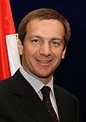 | 14 Apr 2009 - 29 May 2010 Gordon Bajnai  (b. 1968)
 | 29 May 2010 - Viktor Orbán (2nd time) (s.a.)
¹Formal styles of the prime ministers: Miniszterelnök (minister-president) to 5 Sep 1949, 24 Oct - 4 Nov 1956, and from 23 Oct 1989; a Minisztertanács elnöke (president of the Council of Ministers) 5 Sep 1949 - 24 Oct 1956, 28 Jan 1958 - 30 Jun 1965, and 15 May 1975 - 23 Oct 1989; a Magyar Forradalmi Munkás-Paraszt Kormány elnöke (president of the Hungarian Revolutionary Workers' and Peasants' Government) 4 Nov 1956 - 28 Jan 1958 and 30 Jun 1965 - 15 May 1975.
Allied (Soviet) Occupation
Soviet Military Representative of the Headquarters of the High Command
19 Oct 1944 - 20 Jan 1945 Semyon Konstantinovich Timoshenko (b. 1895 - d. 1970) Mil
Chairman of the Allied (Soviet) Control Commission
20 Jan 1945 - 15 Sep 1947 Kliment Yefremovich Voroshilov (b. 1881 - d. 1969) Mil
(Soviet Union)(absent from Feb 1946)
Feb 1946 - 15 Sep 1947 Vladimir Petrovich Sviridov (b. 1897 - d. 1963) Mil
(Soviet Union)(acting for Voroshilov)
German Occupation
Commander of the German Defense Force (Wehrmacht) in Hungary
1 Apr 1944 - 4 Apr 1945 Hans von Greiffenberg (b. 1893 - d. 1951) Mil
Romanian Occupation
Commander of Romanian Forces in Hungary (in Budapest)
4 Aug 1919 - 14 Nov 1919 Gheorghe D. Mărdărescu (b. 1866 - d. 1938) Mil
Inter-Allied Military Mission (1918-1927)
Chiefs of the Inter-Allied Military Mission in Budapest
(subordinated to general commander-in-chief of the Allied Armies of the Orient)
26 Nov 1918 - 25 Mar 1919 Fernand Vix (France) (b. 1876 - d. 1941) Mil
25 Mar 1919 - 5 Aug 1921 ....
Presidents of the Inter-Allied Military Commission Mission of Control in Hungary
(subordinated to the president of the Allied Military Committee of Versailles)
5 Aug 1921 - 31 Aug 1922 Luigi Zuccari (Italy) (b. 1847 - d. 1925) Mil
1 Sep 1922 - 30 May 1924 Alfredo Guzzoni (1st time)(Italy) (b. 1877 - d. 1965) Mil
31 May 1924 - 14 Jun 1925 Giuseppe Campana (Italy) Mil
15 Jun 1925 - 31 Mar 1927 Alfredo Guzzoni (2nd time)(Italy) (s.a.) Mil
Noble and Ecclesiastical Titles (in Hungarian/German): báró/freiherr = baron; bíboros/kardinal = cardinal; érsek/erzbischof = archbishop; főherceg/erzherzog = archduke; fejedelem/fürst = prince; gróf/graf = count; herceg/herzog = duke; püspök/bischof = bishop; vitéz/ritter = knight.
(a) 25 Dec 1000 - 1102 (in Latin): Dei gratia, Hungariae rex; (in Hungarian): Isten kegyelméből, Magyarország Királya ("By the Grace of God, of Hungary King");
(b) 1102 - 22 Jul 1540 (in Latin): Dei gratia, Hungariae, Dalmaciae, Croaciae, &c. Rex; (in Hungarian): Isten kegyelméből, Magyarország, Dalmácia, Horvátország, stb. Királya ("By the Grace of God, of Hungary, Dalmatia, Croatia, etc. King");
(c) 22 Jul 1540 - 1 Oct 1758 (in Latin): Dei gratia, Hungariae, Dalmatiae, Croatiae, Sclavoniae, &c. Rex, (from 1722) Transylvaniae Princeps; (in Hungarian): Isten kegyelméből, Magyarország, Dalmácia, Horvátország, Szlavónia, stb. Királya, (from 1722) Erdély Fejedelme; (in German): Von Gottes Gnaden, Ungarns, Dalmatiens, Kroatiens, Slawoniens, etc. König, (from 1722) Fürst von Siebenbürgen ("By the Grace of God, of Hungary, Dalmatia, Croatia, Slavonia, etc. King, [from 1722] Prince of Transylvania");
(d) 1 Oct 1758 - 10 Mar 1867 (in Hungarian): Isten kegyelméből, A Magyarország, Dalmácia, Horvátország, Szlavónia, stb. Apostoli Királya, (from 1765) Erdély Nagyfejedelme; (in Latin): Dei gratia, Hungariae, Dalmatiae, Croatiae, Sclavoniae, &c. Rex Apostolicus, (from 1765) Magnus Princeps Transylvaniae; (in German): Von Gottes Gnaden, Ungarns, Dalmatiens, Kroatiens, Slawoniens, etc. Apostolischer König, (from 1765) Grossfürst von Siebenbürgen ("By the Grace of God, of Hungary, Dalmatia, Croatia, Slavonia, etc. Apostolic King, [from 1765] Grand Prince of Transylvania"), [for full style see under Austria];
(e) 10 Mar 1867 - 16 Nov 1918: Isten kegyelméből, Magyar, Dalmát, Horvát, Tót, stb. országok Apostoli Királya, Erdély Nagyfejedelme; (in German): Von Gottes Gnaden, Ungarns, Dalmatiens, Kroatiens, Slawoniens, etc. Länder Apostolischer König, Grossfürst von Siebenbürgen ("By the Grace of God, of Hungary, Dalmatia, Croatia, Slavonia, etc. lands Apostolic King, Grand Prince of Transylvania"), [for full style see under Austria];
(f) 20 Oct 1921 - 24 Oct 1921: Magyarország Apostoli Királya ("Apostolic King of Hungary");
(g) 1 Mar 1920 - 15 Oct 1944: Ő Főméltósága a Magyar Királyság Kormányzója ("His Serene Highness the Governor of the Hungarian Kingdom");
The style apostoli (apostolic) was granted by the Pope on 19 Aug 1758, effective 1 Oct 1758.
The term Kyrálynö (queen-regnant) literally means "female-king", and was rendered Rex (not as Regina) in the official Latin, the term Királynö is therefor different from Kyrályné (queen-consort}.
²The Palatine, in Latin palatinus regni, in Hungarian nádorispán, was the traditional highest court official of the kingdom, who stood at the head of the magnates and if necessary was called upon to mediate between the crown and the estates. No appointments to this exalted office were made after the 1848-49 revolution.
³Formal styles of the prime ministers: Miniszterelnök (minister-president) 10 Mar 1867 - 5 Sep 1949, 24 Oct - 4 Nov 1956, and from 23 Oct 1989; a Minisztertanács elnöke (president of the Council of Ministers) 5 Sep 1949 - 24 Oct 1956, 278 Jan 1958 - 30 Jun 1965, and 15 May 1975 - 23 Oct 1989; a Magyar Forradalmi Munkás-Paraszt Kormány elnöke (president of the Hungarian Revolutionary Workers' and Peasants' Government) 4 Nov 1956 - 27 Jan 1958 and 30 Jun 1965 - 15 May 1975; and during 16 Oct 1944 - 28 Mar 1945 Szálasi was Kormányelnök (government president).
Territorial Disputes: Bilateral government, legal, technical and economic working group negotiations continue since 2006 with Slovakia over Hungary's failure to complete its portion of the Gabčíkovo-Nagymaros hydroelectric dam project along the Danube; as a member state that forms part of the EU's external border, Hungary has implemented the strict Schengen border rules.
Party abbreviations: Fidesz-MPP = Fiatal Demokraták Szövetsége "Fidesz" - Magyar Polgári Szövetség (Alliance of Young Democrats "Fidesz"–Hungarian Civic Union, conservative, center-right, from 2010 soft Eurosceptic, 1988-2003 as Fiatal Demokraták Szövetsége [Alliance of Young Democrats], est.30 Mar 1988); FKgP = Független Kisgazda-, Földmunkás és Polgári Párt (Independent Smallholders, Agrarian Workers and Civic Party, christian democratic, agrarian, radical populist, agrarian, 12 Jan 1908-2 Feb 1922, merged into KFKP, 12 Oct 1930-1949, re-est.18 Nov 1988); MDF = Magyar Demokrata Fórum (Hungarian Democratic Forum, center-right, christian-democratic, est.27 Sep 1987); MSzDP = Magyar Szociáldemokrata Párt (Hungarian Social Democratic Party, social-democratic, 7 Dec 1890-12 Jun 1948, merged into MDP, re-est.9 May 1989); MSzP = Magyar Szocialista Párt (Hungarian Socialist Party, socialist, former MSzMP, est.7 Oct 1989); SzDSz = Szabad Demokraták Szövetsége – a Magyar Liberális Párt (Alliance of Free Democrats–Hungarian Liberal Party, liberal, est.13 Nov 1988); Mil = Military;
- Former parties: 48AP = 48-as Alkotmánypárt ("48 Constitution Party, traditionalist conservative, former FNP, 25 Jan-7 Nov 1918); BP = Balközép Párt (National Party, center-left, pro-independence, 1867-1 Mar 1875, merged into SzP); DP = Deák-párt (Deák Party, liberal reform, moderate, 1867-1 Mar 1875, merged into SzP); EP = Ellenzéki Párt (Opposition Party, liberal nationalist, 15 Mar 1847-13 Aug 1849); FNP/F48 = Függetlenségi és Negyvennyolcas [48-as] Párt (Independence and Forty-eight ["48] Party, conservative, merger of FP and NFP/48FP, 29 Sep 1884-25 Jan 1918 then renamed 48AP; Mihály Károlyi faction of FNP separates as F48-"Károlyi Párt" [F48-Károlyi Party] 9 Aug 1916-1919); FP = Függetlenségi Párt (Independence Party, 1874-29 Sep 1884, merged into FNP/F48); KFKP = Keresztény-Keresztyén Földmíves-, Kisgazda- és Polgári Párt "Egységes Párt" (Christian Smallholders', Agricultural Labourers' and Citizens' Party "Unified Party", conservative, merger of FKgP, KNEP, and OKFP, 2 Feb 1922-27 Oct 1932, then NEP); KMP = Kommunisták Magyarországi Pártja (Hungarian Communist Party, communist, 24 Nov 1918-21 Mar 1919, then MSzP; re-est.1922-1943); KNEP = Keresztény Nemzeti Egyesülés Pártja (Christian National Union Party, conservative, christian-socialist, Aug-Oct 1919 named Keresztény Nemzeti Párt [Christian National Party], 25 Oct 1919-2 Feb 1922, merged into KFKP); KsP = Keresztényszociális Néppárt (Christian Social People's Party, christian social, catholic, 3 Feb 1918 - Apr 1919, merged into KNEP); MDP = Magyar Dolgozók Pártja (Hungarian Workers' Party, merger of MSzDP and MKP, 12 Jun 1948-30 Oct 1956, then MSzMP); MEP = Magyar Élet Pártja (Party of Hungarian Life, far-right, nationalist, 22 Feb 1939-1944?); MKP = Magyar Kommunista Párt (Hungarian Communist Party, 8 Oct 1944 - 13 Jun 1948, merged into MDP); MSzMP = Magyar Szocialista Munkáspárt (Hungarian Socialist Workers' Party, communist, split from MDP, 1 Nov 1956-7 Oct 1989); MSzP = Magyar Szocialista Párt (Hungarian Socialist Party, democratic socialist, merger of MSzDP and KMP, 21 Mar 1919-1 Aug 1919); NEP = Nemzeti Egység Pártja (National Unity Party, christian conservative, populist, union of FKgP and KFKP, 27 Oct 1932-1939?); NFP/48FP = Negyvennyolcas [48-as] Függetlenségi Párt (Forty-eight ["48] Independence Party, compromise opposition, radical liberal, 17 May 1874-29 Sep 1884, merged into FNP/F48); NMP = Nemzeti Munkapárt (National Labour Party, liberal, 19 Feb 1910-22 Oct 1918); NykP = Nyilaskeresztes Párt – Hungarista Mozgalom (Arrow Cross Party-Hungarist Movement, fascist, nationalist, Turanism, pro-German, 8 Mar 1939-28 Mar 1945); OAP = Országos Alkotmánypárt (National Constitution Party, liberal, 18 Nov 1905-Nov 1918); OKFP = Országos Kisgazda- és Földmíves Párt (National Christian Smallholders' Party, agrarian, 29 Nov 1919-2 Feb 1922, merged into KFKP); PRP = (Országos) Polgári Radikális Párt ([National] Civil Radical Party, radical liberal, 6 Jun 1914-22 Mar 1919); SzP = Szabadelvű Párt (Liberal Party, liberal, merger of BP and DP, 1 Mar 1875-11 Apr 1906)
Serbo-Hungarian Republic of Baranya
14 Nov 1918 Baranya county (capital Pécs/Pečuj) and Bács-Bodrog county (capital
Zombor/Sombor) of Hungary occupied Serbia/Yugoslavia.
19.. Civil administration organized.
4 Jun 1920 By peace Treaty of Trianon area to be partly restored to Hungary
(ratified 31 Jul 1921).
14 Aug 1921 Serbo-Hungarian Republic of Baranya (Baranyai Szerb-Magyar
Köztársaság/Srpsko-mađarska Republika Baranja) proclaimed in
rebellion.
21 Aug 1921 Yugoslav forces withdrawn, Hungarian forces take over (on 21 Aug
1921 in Baja, 22 Aug 1921 in Pécs, completed 25 Aug 1921).
Baranya county (mostly) restored to Hungary, Bács-Bodrog county
(mostly) remaining with Yugoslavia.
Serbian/Yugoslav Commandants in Pečuj (Pécs)
14 Nov 1918 - Jan 1919 Miloš Cvetić Mil
Jan 1919 - 1919 Stevo Radovanović Mil
1 Aug 1919 - 29 Nov 1919 Kosta Vujičić (b. 1879 - d. 19..) Mil
1919 - 1921 ....
1921 - 21 Aug 1921 Đorđe (Đoka) M. Đorđević (b. 1863 - d. 1935) Mil
(Djordje "Djoka" Djordjević)
Serbian/Yugoslav Government Commissioners
1918 - Jan 1919 Stjepan (Stipan) Vojnić-Tunić (b. 1883 - d. 1928)
27 Jan 1919 - 28 Dec 1919 Vladislav Pandurović (b. 1876 - d. 1944)
Dec 1919 - 18 Aug 1921 Svetislav Rajić (b. 1889 - d. 1941) Non-party?
Chairman of the Management Committee of the Serbo-Hungarian Republic of Baranya
14 Aug 1921 - 22 Aug 1921 Petár Dobrovics (Petar Dobrović) (in rebellion) (b. 1890 - d. 1942) PSP
Hungarian Commanding General in the Southern Marches
22 Aug 1921 - 1921 vitéz Károly Soós bádoki Mil (b. 1869 - d. 1953)
Hungarian Government Commissioner
22 Aug 1921 - 1921 Gyula Kiszely (Julius Kissely) (b. 1869 - d. 1950)
Chairmen of the Inter-Allied Military Mission in Pécs
28 May 1920 - 11 Aug 1921 Raoul Émile Derain (France) Mil
11 Aug 1921 - 25 Sep 1921 Francis William Gosset (U.K.) Mil (b. 1876 - d. 1931)
Party abbreviations: PSP = Pécsi Szocialista Párt (Socialist Party in Pécs, democratic-socialist, Baranya regionalist, split from MSzDP, 14 Jun 1920-1921); Mil = Military
Ottoman Hungary 1541 - 1686
29 Aug 1541 Ottoman rule in Buda (Ofen) by submission. The Danube/Tisza area
becomes an Ottoman province (Budin Eyalet), Ottoman intervention
reduces the Habsburg sphere.
2 Sep 1686 Austrian Habsburg forces liberate Buda (Ofen).
26 Jan 1699 Austrian Habsburgs expel remaining Ottoman forces.
Beylerbeys of Buda
Sep 1541 - Feb 1542 Uzun Süleyman Pasha
Feb 1542 - May 1543 Küçük Bali Pasha
16 May 1543 - Aug 1548 Yahyapashazade Muhammad Pasha (d. 1548)
Sep 1548 - May 1551 Gazi Gasim Pasha (1st time)
May 1551 - Aug 1553 Hadim Ali Pasha (1st time) (d. 1557)
2 Oct 1553 - 23 Feb 1556 Toygun Pasha (1st time)
23 Feb 1556 - 14 Feb 1557 Hadim Ali Pasha (2nd time) (s.a.)
14 Feb 1557 - 6 Aug 1557 Haci Muhammad Pasha
19 Aug 1557 - 4 Nov 1558 Gazi Gasim Pasha (2nd time)
4 Nov 1558 - Jun 1559 Toygun Pasha (2nd time)
21 Jun 1559 - Nov 1563 Güzelce Rüstem Pasha (d. 1563)
18 Nov 1563 - Jun 1564 Zal Mahmut Pasha
Jun 1564 - Jul 1564 Hasan Bey (acting)
Jul 1564 - Oct 1564 Arslan Bey (acting)
Oct 1564 - 19 May 1565 Iskender Pasha
19 May 1565 - 3 Aug 1566 Yahyapashazade Arslan Pasha (d. 1566)
3 Aug 1566 - 1 Oct 1578 Sokullu Mustafa Pasha (d. 1578)
Oct 1578 - May 1580 Kara Üveyis Pasha (d. 1591)
May 1580 - 9 Oct 1583 Kalaylikoz Ali Pasha (1st time)
9 Oct 1583 - May 1586 Frenk (Payzen) Yusuf Pasha (1st time)
May 1586 - 22 Feb 1587 Kalaylikoz Ali Pasha (2nd time)
Mar 1587 - 28 Nov 1588 Frenk (Payzen) Yusuf Pasha (2nd time)
29 Nov 1588 - Sep 1590 Ferhad Pasha
Nov 1590 - 31 Jan 1592 Sofu Sinan Pasha (1st time)
31 Jan 1592 - 28 Jan 1593 Sinanpashazade Mehmet Pasha (1st time)
Jan 1593 - Aug 1594 Mehmetpashazade Hasan Pasha
Aug 1594 - 9 May 1595 Sinanpashazade Mehmet Pasha (2nd time)
9 May 1595 - Aug 1595 Mihaliçli Ahmet Pasha (1st time)
Aug 1595 - May 1596 Sofu Sinan Pasha (2nd time)
May 1596 - 13 Oct 1596 Mihaliçli Ahmet Pasha (2nd time)
Oct 1596 - 31 Jan 1597 Ali Pasha
Feb 1597 - 11 Oct 1598 Mihaliçli Ahmet Pasha (3rd time)
11 Oct 1598 - Aug 1599 Dev Süleyman Pasha
Aug 1599 - Nov 1599 Tiryaki Hasan Pasha (1st time) (b. 1530? - d. 1611)
Nov 1599 - Sep 1600 Lala Mehmed Pasha (1st time)
Sep 1600 - Apr 1601 Tiryaki Hasan Pasha (2nd time) (s.a.)
Apr 1601 - 15 Oct 1601 Minkarkuşu Mehmet Pasha
15 Oct 1601 - Jul 1602 Lala Mehmed Pasha (2nd time)
Jul 1602 - Aug 1604 Kadizade Ali Pasha (1st time)
Aug 1604 - May 1605 Bektash Pasha
May 1605 - Oct 1605 Boşnak Mustafa Pasha
12 Oct 1605 - 28 Nov 1609 Kadizade Ali Pasha (2nd time)
28 Nov 1609 - Jan 1614 Teriali Hasan Pasha (3rd time) (s.a.)
Feb 1614 - 17 Oct 1614 Sefer Pasha
17 Oct 1614 - Dec 1616 Kadizade Ali Pasha (3rd time)
3 Dec 1616 - Jun 1617 Sofu Mehmet Pasha (1st time) (d. 1626)
3 Jun 1617 - 6 May 1618 Nakkash Hasan Pasha
6 May 1618 - Feb 1621 Karakash Mehmet Pasha
Feb 1621 - 9 Dec 1621 Sofu Mehmet Pasha (2nd time) (s.a.)
9 Dec 1621 - Feb 1622 Kenaan Pasha
Feb 1622 - 14 Oct 1622 Sufi Mehmet Pasha (3rd time) (s.a.)
14 Oct 1622 - Oct 1622 Deli Dervish Pasha
Nov 1622 - Sep 1623 Sufi Mehmet Pasha (4th time) (s.a.)
Sep 1623 - Oct 1623 Pir Mehmet Pasha
Oct 1623 - Aug 1626 Sufi Mehmet Pasha (5th time) (s.a.)
Aug 1626 - Feb 1630 Damat Murtaza Pasha
Feb 1630 - Oct 1631 Hasan Pasha
Oct 1631 Bayram Pasha (d. 1638)
Oct 1631 - 30 Jun 1634 Boşnak Musa Pasha (1st time)
30 Jun 1634 - Jul 1634 Silahtar Hüseyin Pasha
Jul 1634 Boşnak Musa Pasha (2nd time)
Jul 1634 - 29 May 1635 Cafer Pasha (d. 1635)
29 May 1635 - Feb 1637 Nasuhpashazade Hüseyin Pasha
20 Feb 1637 - 23 Feb 1638 Boşnak Musa Pasha (3rd time)
23 Feb 1638 - 5 Feb 1639 Tabaniyassi Mehmet Pasha (d. 1639)
5 Feb 1639 - 19 Feb 1640 İbshir Mustafa Pasha
19 Feb 1640 - 21 Feb 1640 Silahtar Mustafa Pasha
Feb 1640 - 12 Mar 1644 Koca Musa Pasha (d. 1647)
12 Mar 1644 - Oct 1644 Mirahor Osman Pasha
Oct 1644 - 11 Aug 1645 Deli Hüseyin Pasha (d. 1259)
11 Aug 1645 - 9 Sep 1646 Nakkash Mustafa Pasha
9 Sep 1646 - 2 Nov 1647 Murteza Pasha
2 Nov 1647 - 5 Nov 1647 Hamzapashazade Mehmet Pasha (1st time) (d. 1658)
5 Nov 1647 - Nov 1647 Fazil Pasha
Nov 1647 - 30 Mar 1648 Hamzapashazade Mehmet Pasha (2nd time) (s.a.)
30 Mar 1648 - 6 Aug 1650 Siyavush Pasha (d. 1656)
6 Aug 1650 - 9 Sep 1653 Kara Murat Pasha
9 Sep 1653 - 11 Sep 1655 Sari Kenan Pasha (d. 1655)
Sep 1655 - 2 May 1656 Gürcü Kenan Pasha (1st time)
2 May 1656 - 20 Nov 1656 Fazil Pasha
20 Nov 1656 - 12 Nov 1658 Gürcü Kenan Pasha (2nd time)
12 Nov 1658 - Dec 1658 Deli Hüseyin Pasha (d. 1659)
3 Dec 1658 - Jun 1659 Gürcü Kenan Pasha (3rd time)
21 Mar 1659 - 28 May 1660 Seydi Ahmet Pasha (b. 1617 - d. 1660)
28 May 1660 - Feb 1663 Boşnak İsmail Pasha (d. 1664)
Feb 1663 - May 1663 Gürcü Mehmed Pasha (1st time) (d. 1665)
May 1663 - 20 Oct 1664 Sari Hüseyin Pasha (d. 1683)
20 Oct 1664 - Mar 1666 Gürcü Mehmed Pasha (2nd time) (s.a.)
7 Apr 1666 - 22 May 1667 Cerrah Kasim Pasha
19 May 1667 - 22 Oct 1667 Söhrab Mehmet Pasha
28 Oct 1667 - 30 Oct 1670 Mahmut Pasha
30 Oct 1670 - Feb 1672 Uzun İbrahim Pasha (1st time) (d. 1683)
Feb 1672 - 13 Apr 1673 Canpulatzade Hüseyin Pasha
13 Apr 1673 - 14 Sep 1675 Uzun İbrahim Pasha (2nd time) (s.a.)
14 Jun 1675 - Mar 1677 Suyolcu Ali Pasha
Mar 1677 - Oct 1677 Halil Pasha
Oct 1677 - 14 Sep 1683 Uzun İbrahim Pasha (3rd time) (s.a.)
14 Sep 1683 - 10 Aug 1684 Kara Mehmet Pasha (d. 1684)
Aug 1684 - Nov 1684 Şeytan İbrahim Pasha (d. 1685)
Nov 1684 - 1 Sep 1686 Arnavut Abdurrahman Abdi Pasha (b. 1616 - d. 1686)

Ministries, etc.
Key ministries
Foreign Affairs
Ministers
22 Dec 1944 - 31 May 1947 János Gyöngyösi (b. 1893 - d. 1951)
31 May 1947 - 24 Sep 1947 Ernö Mihályfi (b. 1898 - d. 1972)
24 Sep 1947 - 5 Aug 1948 Erik Molnár (1st time) (b. 1894 - d. 1966)
5 Aug 1948 - 11 Jun 1949 László Rajk (b. 1909 - d. 1949)
11 Jun 1949 - 12 May 1951 Gyula Kállai (b. 1910 - d. 1996)
12 May 1951 - 12 Nov 1952 Károly Kiss (b. 1903 - d. 1958)
12 Nov 1952 - 4 Jul 1953 Erik Molnár (2nd time) (s.a.)
4 Jul 1953 - 30 Jul 1956 János Boldoczki (b. 1912 - d. 1988)
30 Jul 1956 - 30 Oct 1956 Imre Horváth (1st time) (b. 1901 - d. 1958)
1 Nov 1956 - 4 Nov 1956 Imre Nagy (b. 1896 - d. 1958)
4 Nov 1956 - 3 Feb 1958 Imre Horváth (2nd time) (s.a.)
15 Feb 1958 - 13 Sep 1961 Endre Sik (b. 1891 - d. 1978)
13 Sep 1961 - 14 Dec 1973 János Péter (b. 1910 - d. 1999)
14 Dec 1973 - 8 Jul 1983 Frigyes Puja (b. 1921 - d. 2008)
8 Jul 1983 - 10 May 1989 Péter Várkonyi (b. 1931 - d. 2008)
10 May 1989 - 23 May 1990 Gyula Horn (b. 1932 - d. 2013)
23 May 1990 - 15 Jul 1994 Géza Jeszenszky (b. 1941)
15 Jul 1994 - 8 Jul 1998 László Kovács (1st time) (b. 1939)
8 Jul 1998 - 27 May 2002 János Martonyi (1st time) (b. 1944)
27 May 2002 - 31 Oct 2004 László Kovács (2nd time) (s.a.)
1 Nov 2004 - 9 Jun 2006 Ferenc Somogyi (b. 1945)
9 Jun 2006 - 20 Apr 2009 Kinga Göncz (f) (b. 1947)
20 Apr 2009 - 29 May 2010 Péter Balázs (b. 1941)
29 May 2010 - 6 Jun 2014 János Martonyi (2nd time) (s.a.)
6 Jun 2014 - 23 Sep 2014 Tibor Navracsics (b. 1966)
23 Sep 2014 - Péter Szijjártó (b. 1978)
Defense
Ministers
22 Dec 1944 - 15 Nov 1945 János Vörös (b. 1891 - d. 1968)
15 Nov 1945 - 25 Jul 1946 Jenö Tombor (b. 1880 - d. 1946)
20 Aug 1946 - 14 Mar 1947 Albert Bartha (b. 1877 - d. 1960)
14 Mar 1947 - 24 Sep 1947 Lajos Dinnyés (b. 1901 - d. 1961)
24 Sep 1947 - 9 Sep 1948 Péter Vérés (b. 1896 - d. 1970)
9 Sep 1948 - 4 Jul 1953 Mihály Farkas (b. 1904 - d. 1965)
4 Jul 1953 - 27 Oct 1956 István Bata (b. 1910 - d. 1982)
27 Oct 1956 - 3 Nov 1956 Károly Janza (b. 1914 - d. 2001)
3 Nov 1956 - 4 Nov 1956 Pál Maléter (b. 1911 - d. 1958)
4 Nov 1956 - 1 Mar 1957 Ferenc Münnich (b. 1886 - d. 1967)
1 Mar 1957 - 17 May 1960 Géza Révész (b. 1902 - d. 1977)
17 May 1960 - 6 Dec 1984 Lajos Czinege (b. 1924 - d. 1998)
6 Dec 1984 - 15 Dec 1985 István Oláh (b. 1926 - d. 1985)
30 Dec 1985 - 23 May 1990 Ferenc Kárpáti (b. 1926 - d. 2013)
23 May 1990 - 15 Jul 1994 Lajos Für (b. 1930 - d. 2013)
15 Jul 1994 - 8 Jul 1998 György Keleti (b. 1946)
8 Jul 1998 - 27 May 2002 János Szabó (b. 1941)
27 May 2002 - 9 Jun 2006 Ferenc Juhász (b. 1960)
9 Jun 2006 - 29 May 2010 Imre Szekeres (b. 1950)
29 May 2010 - 9 Sep 2015 Csaba Hende (b. 1960)
10 Sep 2015 - 18 May 2018 István Simicskó (b. 1961)
18 May 2018 - Tibor Benkö (b. 1955)
Interior
9 Jun 2006 - 29 May 2010 abolished
Ministers
22 Dec 1944 - 15 Nov 1945 Ferenc Erdei (b. 1910 - d. 1971)
15 Nov 1945 - 20 Mar 1946 Imre Nagy (b. 1896 - d. 1958)
20 Mar 1946 - 5 Aug 1948 László Rajk (b. 1909 - d. 1949)
5 Aug 1948 - 23 Jun 1950 János Kádár (b. 1912 - d. 1989)
23 Jun 1950 - 20 Apr 1951 Sándor Zöld (b. 1913 - d. 1951)
20 Apr 1951 - 14 Nov 1952 Árpád Házi (b. 1908 - d. 1970)
14 Nov 1952 - 4 Jul 1953 József Györe (b. 1902 - d. 1985)
4 Jul 1953 - 6 Jul 1954 Ernö Gerö (b. 1898 - d. 1980)
6 Jul 1954 - 27 Oct 1956 László Piros (b. 1917 - d. 2006)
27 Oct 1956 - 31 Oct 1956 Ferenc Münnich (1st time) (b. 1886 - d. 1967)
3 Nov 1956 - 4 Nov 1956 György Ádám (b. 1911 - d. 1974)
4 Nov 1956 - 28 Feb 1957 Ferenc Münnich (2nd time) (s.a.)
28 Feb 1957 - 13 Sep 1961 Béla Biszku (b. 1921 - d. 2016)
13 Sep 1961 - 7 Dec 1963 János Pap (b. 1925 - d. 1994)
7 Dec 1963 - 27 Jun 1980 András Benkei (b. 1923 - d. 1991)
27 Jun 1980 - 28 Mar 1985 István Horváth (1st time) (b. 1935)
1 Apr 1985 - 16 Dec 1987 János Kamara (b. 1927 - d. 2000)
16 Dec 1987 - 23 Jan 1990 István Horváth (2nd time) (s.a.)
23 Jan 1990 - 23 May 1990 Zoltán Gál (b. 1940)
23 May 1990 - 20 Dec 1990 Balázs Horváth (b. 1942 - d. 2006)
20 Dec 1990 - 21 Dec 1993 Péter Boross (b. 1928)
21 Dec 1993 - 15 Jul 1994 Imre Kónya (b. 1947)
15 Jul 1994 - 8 Jul 1998 Gábor Kuncze (b. 1950)
8 Jul 1998 - 27 May 2002 Sándor Pintér (1st time) (b. 1948)
27 May 2002 - 9 Jun 2006 Mónika Lamperth (f) (b. 1957)
29 May 2010 - Sándor Pintér (2nd time) (s.a.)
Finance
29 May 2010 - 18 May 2018 Ministry of Economy
Ministers
22 Dec 1944 - 21 Jul 1945 István Vásáry (b. 1887 - d. 1955)
21 Jul 1945 - 15 Nov 1945 Imre Oltványi (b. 1893 - d. 1963)
15 Nov 1945 - 26 Aug 1946 Ferenc Gordon (b. 1893 - d. 1971)
26 Aug 1946 - 14 Mar 1947 Jenö Rácz (b. 1907 - d. 1981)
14 Mar 1947 - 4 Dec 1948 Miklós Nyárádi (b. 1905 - d. 1976)
10 Dec 1948 - 11 Jun 1949 Ernö Gerö (b. 1898 - d. 1980)
11 Jun 1949 - 24 Feb 1950 István Kossa (1st time) (b. 1904 - d. 1965)
24 Feb 1950 - 27 Oct 1956 Károly Olt (b. 1904 - d. 1985)
27 Oct 1956 - 9 May 1957 István Kossa (2nd time) (s.a.)
9 May 1957 - 5 Jan 1960 István Antos (b. 1908 - d. 1960)
15 Jan 1960 - 27 Nov 1962 Rezsö Nyers (b. 1923 - d. 2018)
27 Nov 1962 - 14 Apr 1967 Mátyás Tímár (b. 1923)
14 Apr 1967 - 13 May 1971 Péter Vályi (b. 1919 - d. 1973)
13 May 1971 - 27 Jun 1980 Lajos Faluvégi (b. 1924 - d. 1999)
27 Jun 1980 - 31 Dec 1986 István Hetényi (b. 1926 - d. 2008)
1 Jan 1987 - 16 Dec 1987 Péter Medgyessy (1st time) (b. 1942)
16 Dec 1987 - 10 May 1989 Miklós Villányi (b. 1931)
10 May 1989 - 23 May 1990 László Békesi (1st time) (b. 1942)
23 May 1990 - 20 Dec 1990 Ferenc Rabár (b. 1929 - d. 1999)
20 Dec 1990 - 11 Feb 1993 Mihály Kupa (b. 1941)
24 Feb 1993 - 15 Jul 1994 Iván Szabó (b. 1934 - d. 2005)
15 Jul 1994 - 28 Feb 1995 László Békesi (2nd time) (s.a.)
1 Mar 1995 - 29 Feb 1996 Lajos Bokros (b. 1954)
1 Mar 1996 - 8 Jul 1998 Péter Medgyessy (2nd time) (s.a.)
8 Jul 1998 - 31 Dec 2000 Zsigmond Járai (b. 1951)
1 Jan 2001 - 27 May 2002 Mihály Varga (1st time) (b. 1965)
27 May 2002 - 16 Feb 2004 Csaba László (b. 1962)
16 Feb 2004 - 25 Apr 2005 Tibor Draskovics (b. 1955)
25 Apr 2005 - 20 Apr 2009 János Veres (b. 1957)
20 Apr 2009 - 29 May 2010 Péter Oszkó (b. 1973)
29 May 2010 - 3 Mar 2013 György Matolcsy (b. 1955)
7 Mar 2013 - Mihály Varga (2nd time) (s.a.)
Justice
Ministers
22 Dec 1944 - 21 Jul 1945 Ágoston Valentiny (b. 1888 - d. 1958)
21 Jul 1945 - 17 Jul 1950 István Ries (b. 1885 - d. 1950)
17 Jul 1950 - 14 Nov 1952 Erik Molnár (1st time) (b. 1894 - d. 1966)
14 Nov 1952 - 8 Feb 1953 Gyula Décsi (b. 1919 - d. 1990)
8 Feb 1953 - 4 Jul 1953 Béla Kovács (b. 1910 - d. 1980)
4 Jul 1953 - 30 Oct 1954 Ferenc Erdei (b. 1910 - d. 1971)
30 Oct 1954 - 4 Nov 1956 Erik Molnár (2nd time) (s.a.)
29 Dec 1956 - 7 Dec 1966 Ferenc Nezvál (b. 1909 - d. 1987)
7 Dec 1966 - 22 Apr 1978 Mihály Korom (b. 1927 - d. 1993)
22 Apr 1978 - 29 Jun 1988 Imre Markója (b. 1931 - d. 2008)
29 Jun 1988 - 23 May 1990 Kálmán Kulcsár (b. 1928 - d. 2010)
23 May 1990 - 15 Jul 1994 István Balsai (b. 1947)
15 Jul 1994 - 8 Jul 1998 Pál Vastagh (b. 1946)
8 Jul 1998 - 27 May 2002 Ibolya Dávid (f) (b. 1954)
27 May 2002 - 4 Oct 2004 Péter Bárándy (b. 1949)
4 Oct 2004 - 31 May 2007 József Petrétei (b. 1958)
1 Jun 2007 - 19 Feb 2008 Albert Takács (b. 1955)
19 Feb 2008 - 15 Dec 2009 Tibor Draskovics (b. 1955)
15 Dec 2009 - 29 May 2010 Imre Forgács (b. 1949)
29 May 2010 - 6 Jun 2014 Tibor Navracsics (b. 1966)
6 Jun 2014 - László Trócsányi (b. 1956)
Parliament
Nemzetgyülés (National Assembly)
Presidents
21 Dec 1944 - 29 Nov 1945 Béla Zsedényi (b. 1894 - d. 1955)
29 Nov 1945 - 5 Feb 1946 Ferenc Nagy (b. 1903 - d. 1979)
7 Feb 1946 - 3 Jul 1947 Béla Varga (b. 1903 - d. 1995)
4 Jul 1947 - 25 Jul 1947 Árpád Szabó (b. 1878 - d. 1948)
Országgyülés (National Assembly)
Presidents
16 Sep 1947 - 8 Jun 1949 Imre Nagy (b. 1896 - d. 1958)
8 Jun 1949 - 23 Aug 1949 Károly Olt (b. 1904 - d. 1985)
23 Aug 1949 - 18 May 1951 Lajos Drahos (b. 1895 - d. 1983)
18 May 1951 - 14 Aug 1952 Imre Dögei (b. 1912 - d. 1964)
18 Aug 1952 - 5 Nov 1962 Sándor Rónai (b. 1892 - d. 1965)
21 Mar 1963 - 14 Apr 1967 Erzsébet Metzker (f) (b. 1915 - d. 1980)
14 Apr 1967 - 12 May 1971 Gyula Kállai (b. 1910 - d. 1996)
12 May 1971 - 19 Dec 1984 Antal Apró (b. 1913 - d. 1994)
19 Dec 1984 - 29 Jun 1988 István Sarlós (b. 1921 - d. 2006)
29 Jun 1988 - 8 Mar 1989 István Stadinger (b. 1927)
10 Mar 1989 - 2 May 1990 Mátyás Szürös (b. 1933)
2 May 1990 - 3 Aug 1990 Árpád Göncz (b. 1922 - d. 2015)
3 Aug 1990 - 28 Jun 1994 György Szabad (b. 1924 - d. 2015)
28 Jun 1994 - 18 Jun 1998 Zoltán Gál (b. 1940)
18 Jun 1998 - 15 May 2002 János Áder (b. 1959)
15 May 2002 - 14 Sep 2009 Katalin Szili (f) (b. 1956)
14 Sep 2009 - 14 May 2010 Béla Katona (b. 1944)
14 May 2010 - 6 Aug 2010 Pál Schmitt (b. 1942)
6 Aug 2010 - László Kövér (b. 1959)
Allied occupation
Chairmen of the Allied Control Commission
20 Jan 1945 - Apr 1946 Kliment Voroshilov (U.S.S.R.) (b. 1881 - d. 1969)
Apr 1946 - 15 Sep 1947 Vladimir Sviridov (U.S.S.R.) (b. 1897 - d. 1963)

INCLUDEPICTURE "http://t0.gstatic.com/images?q=tbn:ANd9GcTDT1jpfS6n_Y4NmsXFnf0dV2uAk854tEHeOSaIXPxUCt7qxHu5xaSaZA" \* MERGEFORMATINET INCLUDEPICTURE "http://t0.gstatic.com/images?q=tbn:ANd9GcTDT1jpfS6n_Y4NmsXFnf0dV2uAk854tEHeOSaIXPxUCt7qxHu5xaSaZA" \* MERGEFORMATINET INCLUDEPICTURE "http://t0.gstatic.com/images?q=tbn:ANd9GcTDT1jpfS6n_Y4NmsXFnf0dV2uAk854tEHeOSaIXPxUCt7qxHu5xaSaZA" \* MERGEFORMATINET INCLUDEPICTURE "http://t0.gstatic.com/images?q=tbn:ANd9GcTDT1jpfS6n_Y4NmsXFnf0dV2uAk854tEHeOSaIXPxUCt7qxHu5xaSaZA" \* MERGEFORMATINET INCLUDEPICTURE "http://t0.gstatic.com/images?q=tbn:ANd9GcTDT1jpfS6n_Y4NmsXFnf0dV2uAk854tEHeOSaIXPxUCt7qxHu5xaSaZA" \* MERGEFORMATINET INCLUDEPICTURE "http://t0.gstatic.com/images?q=tbn:ANd9GcTDT1jpfS6n_Y4NmsXFnf0dV2uAk854tEHeOSaIXPxUCt7qxHu5xaSaZA" \* MERGEFORMATINET INCLUDEPICTURE "http://t0.gstatic.com/images?q=tbn:ANd9GcTDT1jpfS6n_Y4NmsXFnf0dV2uAk854tEHeOSaIXPxUCt7qxHu5xaSaZA" \* MERGEFORMATINET INCLUDEPICTURE "http://t0.gstatic.com/images?q=tbn:ANd9GcTDT1jpfS6n_Y4NmsXFnf0dV2uAk854tEHeOSaIXPxUCt7qxHu5xaSaZA" \* MERGEFORMATINET INCLUDEPICTURE "http://t0.gstatic.com/images?q=tbn:ANd9GcTDT1jpfS6n_Y4NmsXFnf0dV2uAk854tEHeOSaIXPxUCt7qxHu5xaSaZA" \* MERGEFORMATINET INCLUDEPICTURE "http://t0.gstatic.com/images?q=tbn:ANd9GcTDT1jpfS6n_Y4NmsXFnf0dV2uAk854tEHeOSaIXPxUCt7qxHu5xaSaZA" \* MERGEFORMATINET INCLUDEPICTURE "http://t0.gstatic.com/images?q=tbn:ANd9GcTDT1jpfS6n_Y4NmsXFnf0dV2uAk854tEHeOSaIXPxUCt7qxHu5xaSaZA" \* MERGEFORMATINET INCLUDEPICTURE "http://t0.gstatic.com/images?q=tbn:ANd9GcTDT1jpfS6n_Y4NmsXFnf0dV2uAk854tEHeOSaIXPxUCt7qxHu5xaSaZA" \* MERGEFORMATINET INCLUDEPICTURE "http://t0.gstatic.com/images?q=tbn:ANd9GcTDT1jpfS6n_Y4NmsXFnf0dV2uAk854tEHeOSaIXPxUCt7qxHu5xaSaZA" \* MERGEFORMATINET INCLUDEPICTURE "http://t0.gstatic.com/images?q=tbn:ANd9GcTDT1jpfS6n_Y4NmsXFnf0dV2uAk854tEHeOSaIXPxUCt7qxHu5xaSaZA" \* MERGEFORMATINET INCLUDEPICTURE "http://t0.gstatic.com/images?q=tbn:ANd9GcTDT1jpfS6n_Y4NmsXFnf0dV2uAk854tEHeOSaIXPxUCt7qxHu5xaSaZA" \* MERGEFORMATINET INCLUDEPICTURE "http://t0.gstatic.com/images?q=tbn:ANd9GcTDT1jpfS6n_Y4NmsXFnf0dV2uAk854tEHeOSaIXPxUCt7qxHu5xaSaZA" \* MERGEFORMATINET INCLUDEPICTURE "http://t0.gstatic.com/images?q=tbn:ANd9GcTDT1jpfS6n_Y4NmsXFnf0dV2uAk854tEHeOSaIXPxUCt7qxHu5xaSaZA" \* MERGEFORMATINET INCLUDEPICTURE "http://t0.gstatic.com/images?q=tbn:ANd9GcTDT1jpfS6n_Y4NmsXFnf0dV2uAk854tEHeOSaIXPxUCt7qxHu5xaSaZA" \* MERGEFORMATINET INCLUDEPICTURE "http://t0.gstatic.com/images?q=tbn:ANd9GcTDT1jpfS6n_Y4NmsXFnf0dV2uAk854tEHeOSaIXPxUCt7qxHu5xaSaZA" \* MERGEFORMATINET INCLUDEPICTURE "http://t0.gstatic.com/images?q=tbn:ANd9GcTDT1jpfS6n_Y4NmsXFnf0dV2uAk854tEHeOSaIXPxUCt7qxHu5xaSaZA" \* MERGEFORMATINET INCLUDEPICTURE "http://t0.gstatic.com/images?q=tbn:ANd9GcTDT1jpfS6n_Y4NmsXFnf0dV2uAk854tEHeOSaIXPxUCt7qxHu5xaSaZA" \* MERGEFORMATINET INCLUDEPICTURE "http://t0.gstatic.com/images?q=tbn:ANd9GcTDT1jpfS6n_Y4NmsXFnf0dV2uAk854tEHeOSaIXPxUCt7qxHu5xaSaZA" \* MERGEFORMATINET INCLUDEPICTURE "http://t0.gstatic.com/images?q=tbn:ANd9GcTDT1jpfS6n_Y4NmsXFnf0dV2uAk854tEHeOSaIXPxUCt7qxHu5xaSaZA" \* MERGEFORMATINET INCLUDEPICTURE "http://t0.gstatic.com/images?q=tbn:ANd9GcTDT1jpfS6n_Y4NmsXFnf0dV2uAk854tEHeOSaIXPxUCt7qxHu5xaSaZA" \* MERGEFORMATINET INCLUDEPICTURE "http://t0.gstatic.com/images?q=tbn:ANd9GcTDT1jpfS6n_Y4NmsXFnf0dV2uAk854tEHeOSaIXPxUCt7qxHu5xaSaZA" \* MERGEFORMATINET INCLUDEPICTURE "http://t0.gstatic.com/images?q=tbn:ANd9GcTDT1jpfS6n_Y4NmsXFnf0dV2uAk854tEHeOSaIXPxUCt7qxHu5xaSaZA" \* MERGEFORMATINET INCLUDEPICTURE "http://t0.gstatic.com/images?q=tbn:ANd9GcTDT1jpfS6n_Y4NmsXFnf0dV2uAk854tEHeOSaIXPxUCt7qxHu5xaSaZA" \* MERGEFORMATINET INCLUDEPICTURE "http://t0.gstatic.com/images?q=tbn:ANd9GcTDT1jpfS6n_Y4NmsXFnf0dV2uAk854tEHeOSaIXPxUCt7qxHu5xaSaZA" \* MERGEFORMATINET INCLUDEPICTURE "http://t0.gstatic.com/images?q=tbn:ANd9GcTDT1jpfS6n_Y4NmsXFnf0dV2uAk854tEHeOSaIXPxUCt7qxHu5xaSaZA" \* MERGEFORMATINET INCLUDEPICTURE "http://t0.gstatic.com/images?q=tbn:ANd9GcTDT1jpfS6n_Y4NmsXFnf0dV2uAk854tEHeOSaIXPxUCt7qxHu5xaSaZA" \* MERGEFORMATINET INCLUDEPICTURE "http://t0.gstatic.com/images?q=tbn:ANd9GcTDT1jpfS6n_Y4NmsXFnf0dV2uAk854tEHeOSaIXPxUCt7qxHu5xaSaZA" \* MERGEFORMATINET INCLUDEPICTURE "http://t0.gstatic.com/images?q=tbn:ANd9GcTDT1jpfS6n_Y4NmsXFnf0dV2uAk854tEHeOSaIXPxUCt7qxHu5xaSaZA" \* MERGEFORMATINET INCLUDEPICTURE "http://t0.gstatic.com/images?q=tbn:ANd9GcTDT1jpfS6n_Y4NmsXFnf0dV2uAk854tEHeOSaIXPxUCt7qxHu5xaSaZA" \* MERGEFORMATINET INCLUDEPICTURE "http://t0.gstatic.com/images?q=tbn:ANd9GcTDT1jpfS6n_Y4NmsXFnf0dV2uAk854tEHeOSaIXPxUCt7qxHu5xaSaZA" \* MERGEFORMATINET INCLUDEPICTURE "http://t0.gstatic.com/images?q=tbn:ANd9GcTDT1jpfS6n_Y4NmsXFnf0dV2uAk854tEHeOSaIXPxUCt7qxHu5xaSaZA" \* MERGEFORMATINET INCLUDEPICTURE "http://t0.gstatic.com/images?q=tbn:ANd9GcTDT1jpfS6n_Y4NmsXFnf0dV2uAk854tEHeOSaIXPxUCt7qxHu5xaSaZA" \* MERGEFORMATINET INCLUDEPICTURE "http://t0.gstatic.com/images?q=tbn:ANd9GcTDT1jpfS6n_Y4NmsXFnf0dV2uAk854tEHeOSaIXPxUCt7qxHu5xaSaZA" \* MERGEFORMATINET INCLUDEPICTURE "http://t0.gstatic.com/images?q=tbn:ANd9GcTDT1jpfS6n_Y4NmsXFnf0dV2uAk854tEHeOSaIXPxUCt7qxHu5xaSaZA" \* MERGEFORMATINET INCLUDEPICTURE "http://t0.gstatic.com/images?q=tbn:ANd9GcTDT1jpfS6n_Y4NmsXFnf0dV2uAk854tEHeOSaIXPxUCt7qxHu5xaSaZA" \* MERGEFORMATINET INCLUDEPICTURE "http://t0.gstatic.com/images?q=tbn:ANd9GcTDT1jpfS6n_Y4NmsXFnf0dV2uAk854tEHeOSaIXPxUCt7qxHu5xaSaZA" \* MERGEFORMATINET INCLUDEPICTURE "http://t0.gstatic.com/images?q=tbn:ANd9GcTDT1jpfS6n_Y4NmsXFnf0dV2uAk854tEHeOSaIXPxUCt7qxHu5xaSaZA" \* MERGEFORMATINET INCLUDEPICTURE "http://t0.gstatic.com/images?q=tbn:ANd9GcTDT1jpfS6n_Y4NmsXFnf0dV2uAk854tEHeOSaIXPxUCt7qxHu5xaSaZA" \* MERGEFORMATINET INCLUDEPICTURE "http://t0.gstatic.com/images?q=tbn:ANd9GcTDT1jpfS6n_Y4NmsXFnf0dV2uAk854tEHeOSaIXPxUCt7qxHu5xaSaZA" \* MERGEFORMATINET INCLUDEPICTURE "http://t0.gstatic.com/images?q=tbn:ANd9GcTDT1jpfS6n_Y4NmsXFnf0dV2uAk854tEHeOSaIXPxUCt7qxHu5xaSaZA" \* MERGEFORMATINET INCLUDEPICTURE "http://t0.gstatic.com/images?q=tbn:ANd9GcTDT1jpfS6n_Y4NmsXFnf0dV2uAk854tEHeOSaIXPxUCt7qxHu5xaSaZA" \* MERGEFORMATINET INCLUDEPICTURE "http://t0.gstatic.com/images?q=tbn:ANd9GcTDT1jpfS6n_Y4NmsXFnf0dV2uAk854tEHeOSaIXPxUCt7qxHu5xaSaZA" \* MERGEFORMATINET INCLUDEPICTURE "http://t0.gstatic.com/images?q=tbn:ANd9GcTDT1jpfS6n_Y4NmsXFnf0dV2uAk854tEHeOSaIXPxUCt7qxHu5xaSaZA" \* MERGEFORMATINET INCLUDEPICTURE "http://t0.gstatic.com/images?q=tbn:ANd9GcTDT1jpfS6n_Y4NmsXFnf0dV2uAk854tEHeOSaIXPxUCt7qxHu5xaSaZA" \* MERGEFORMATINET INCLUDEPICTURE "http://t0.gstatic.com/images?q=tbn:ANd9GcTDT1jpfS6n_Y4NmsXFnf0dV2uAk854tEHeOSaIXPxUCt7qxHu5xaSaZA" \* MERGEFORMATINET INCLUDEPICTURE "http://t0.gstatic.com/images?q=tbn:ANd9GcTDT1jpfS6n_Y4NmsXFnf0dV2uAk854tEHeOSaIXPxUCt7qxHu5xaSaZA" \* MERGEFORMATINET INCLUDEPICTURE "http://t0.gstatic.com/images?q=tbn:ANd9GcTDT1jpfS6n_Y4NmsXFnf0dV2uAk854tEHeOSaIXPxUCt7qxHu5xaSaZA" \* MERGEFORMATINET INCLUDEPICTURE "http://t0.gstatic.com/images?q=tbn:ANd9GcTDT1jpfS6n_Y4NmsXFnf0dV2uAk854tEHeOSaIXPxUCt7qxHu5xaSaZA" \* MERGEFORMATINET INCLUDEPICTURE "http://t0.gstatic.com/images?q=tbn:ANd9GcTDT1jpfS6n_Y4NmsXFnf0dV2uAk854tEHeOSaIXPxUCt7qxHu5xaSaZA" \* MERGEFORMATINET INCLUDEPICTURE "http://t0.gstatic.com/images?q=tbn:ANd9GcTDT1jpfS6n_Y4NmsXFnf0dV2uAk854tEHeOSaIXPxUCt7qxHu5xaSaZA" \* MERGEFORMATINET INCLUDEPICTURE "http://t0.gstatic.com/images?q=tbn:ANd9GcTDT1jpfS6n_Y4NmsXFnf0dV2uAk854tEHeOSaIXPxUCt7qxHu5xaSaZA" \* MERGEFORMATINET INCLUDEPICTURE "http://t0.gstatic.com/images?q=tbn:ANd9GcTDT1jpfS6n_Y4NmsXFnf0dV2uAk854tEHeOSaIXPxUCt7qxHu5xaSaZA" \* MERGEFORMATINET INCLUDEPICTURE "http://t0.gstatic.com/images?q=tbn:ANd9GcTDT1jpfS6n_Y4NmsXFnf0dV2uAk854tEHeOSaIXPxUCt7qxHu5xaSaZA" \* MERGEFORMATINET INCLUDEPICTURE "http://t0.gstatic.com/images?q=tbn:ANd9GcTDT1jpfS6n_Y4NmsXFnf0dV2uAk854tEHeOSaIXPxUCt7qxHu5xaSaZA" \* MERGEFORMATINET INCLUDEPICTURE "http://t0.gstatic.com/images?q=tbn:ANd9GcTDT1jpfS6n_Y4NmsXFnf0dV2uAk854tEHeOSaIXPxUCt7qxHu5xaSaZA" \* MERGEFORMATINET INCLUDEPICTURE "http://t0.gstatic.com/images?q=tbn:ANd9GcTDT1jpfS6n_Y4NmsXFnf0dV2uAk854tEHeOSaIXPxUCt7qxHu5xaSaZA" \* MERGEFORMATINET INCLUDEPICTURE "http://t0.gstatic.com/images?q=tbn:ANd9GcTDT1jpfS6n_Y4NmsXFnf0dV2uAk854tEHeOSaIXPxUCt7qxHu5xaSaZA" \* MERGEFORMATINET INCLUDEPICTURE "http://t0.gstatic.com/images?q=tbn:ANd9GcTDT1jpfS6n_Y4NmsXFnf0dV2uAk854tEHeOSaIXPxUCt7qxHu5xaSaZA" \* MERGEFORMATINET INCLUDEPICTURE "http://t0.gstatic.com/images?q=tbn:ANd9GcTDT1jpfS6n_Y4NmsXFnf0dV2uAk854tEHeOSaIXPxUCt7qxHu5xaSaZA" \* MERGEFORMATINET INCLUDEPICTURE "http://t0.gstatic.com/images?q=tbn:ANd9GcTDT1jpfS6n_Y4NmsXFnf0dV2uAk854tEHeOSaIXPxUCt7qxHu5xaSaZA" \* MERGEFORMATINET INCLUDEPICTURE "http://t0.gstatic.com/images?q=tbn:ANd9GcTDT1jpfS6n_Y4NmsXFnf0dV2uAk854tEHeOSaIXPxUCt7qxHu5xaSaZA" \* MERGEFORMATINET INCLUDEPICTURE "http://t0.gstatic.com/images?q=tbn:ANd9GcTDT1jpfS6n_Y4NmsXFnf0dV2uAk854tEHeOSaIXPxUCt7qxHu5xaSaZA" \* MERGEFORMATINET INCLUDEPICTURE "http://t0.gstatic.com/images?q=tbn:ANd9GcTDT1jpfS6n_Y4NmsXFnf0dV2uAk854tEHeOSaIXPxUCt7qxHu5xaSaZA" \* MERGEFORMATINET
Compiler FLN

